**Type of Environments**

**Development environment –** where your team build the code or write the code.

**Staging environment –** where the internal tester tests the code the fix the error.

**UAT (User Acceptance testing) –** we forward the application to application/web users for the testing purpose and accordingly will change the code as per his/her requirement.

**Production environment –** Application is running in real-time basis environment.

**Azure Disk Encryption (ADE)**

Server site Encryption (SSE), PMK (Platform manage key), CME (Custom manage key)

By default, encryption is carried out with PMK

Note – When you perform the encryption you can easily move CMK to PMK but early it’s not possible but now possible. We have known that features on Azure are always changing. When you apply encryption set default to custom need to deallocate the VM / server.

Encryption are the 3 types

1. Encryption at rest with customer manage key
2. Double encryption PMK & CMK
3. Confidential encryption with a CMK

Azure key vault – is the manage service that can be used for storing and managing your encryption key & storing certificate, storing secret.

Encryption key are stored in the secure location

Azure key vault

Encryption set

Note – If you delete the encryption set you have to first remove encryption OS disk/ Manage disk & data disk. First you have to remove the encryption set. If you create new server in the same region you no need to set new encryption set.

Step1 create a key vault and fill the all required details as mentioned below.

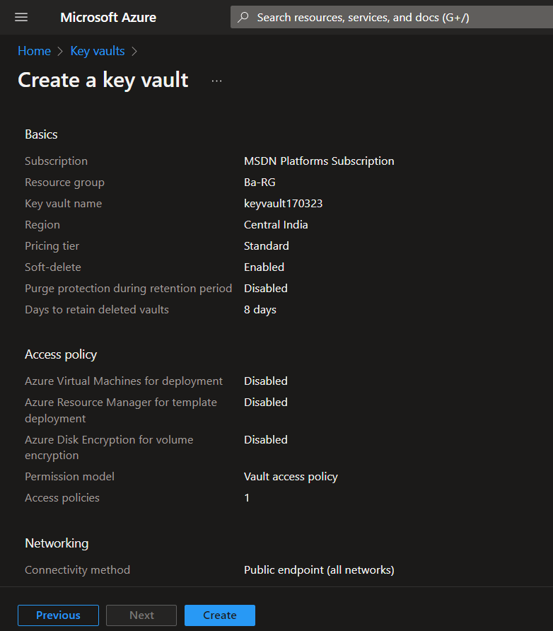

Click on the create button to create a new key vault.

Step2 click on the key and click generate/ impact.

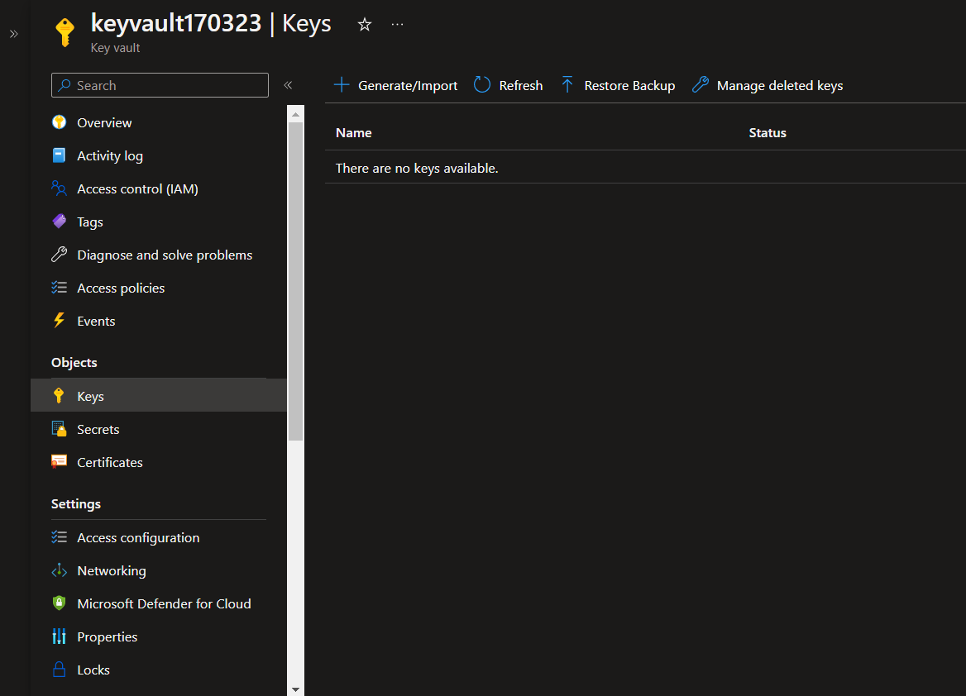

Fill the all the required data

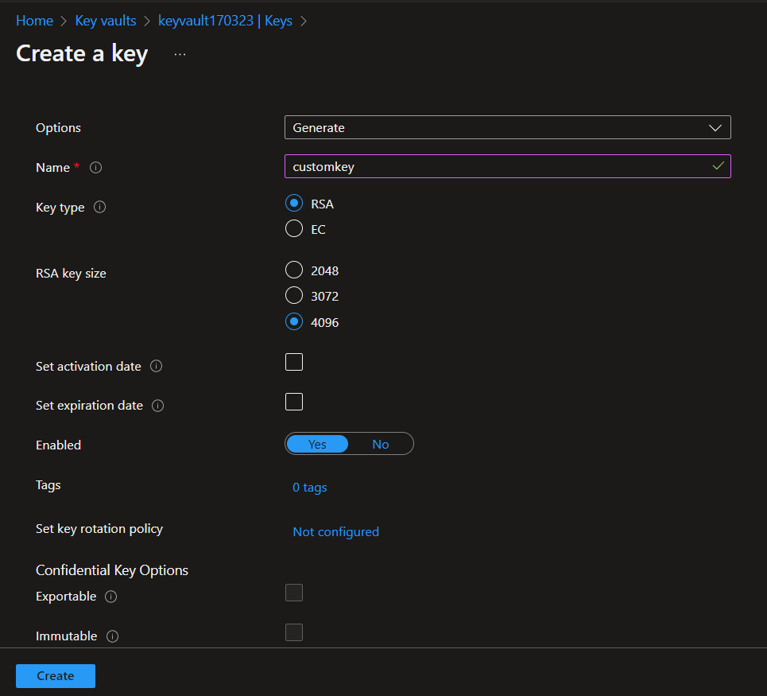

Click on the create button.

Step3 create new disk encryption set and fill the below details

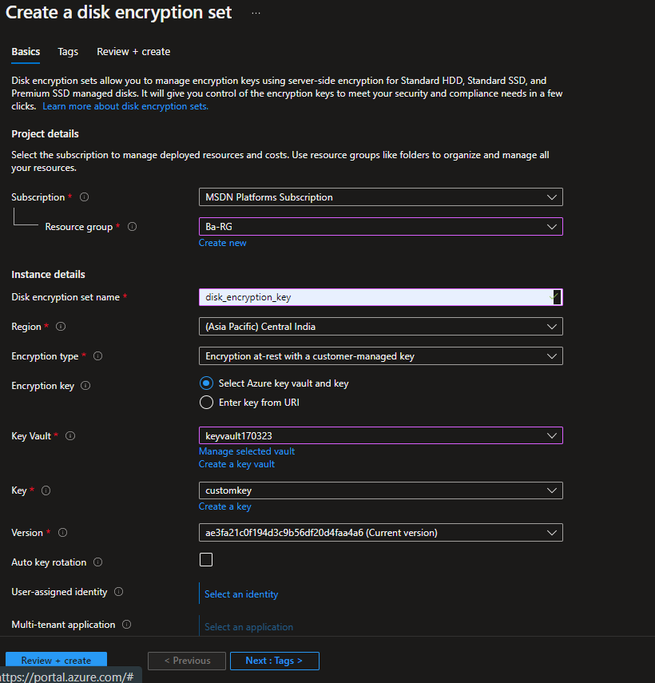

Click review and create.

After creating disk encryption goto the overview and lick on the redline pop up message.

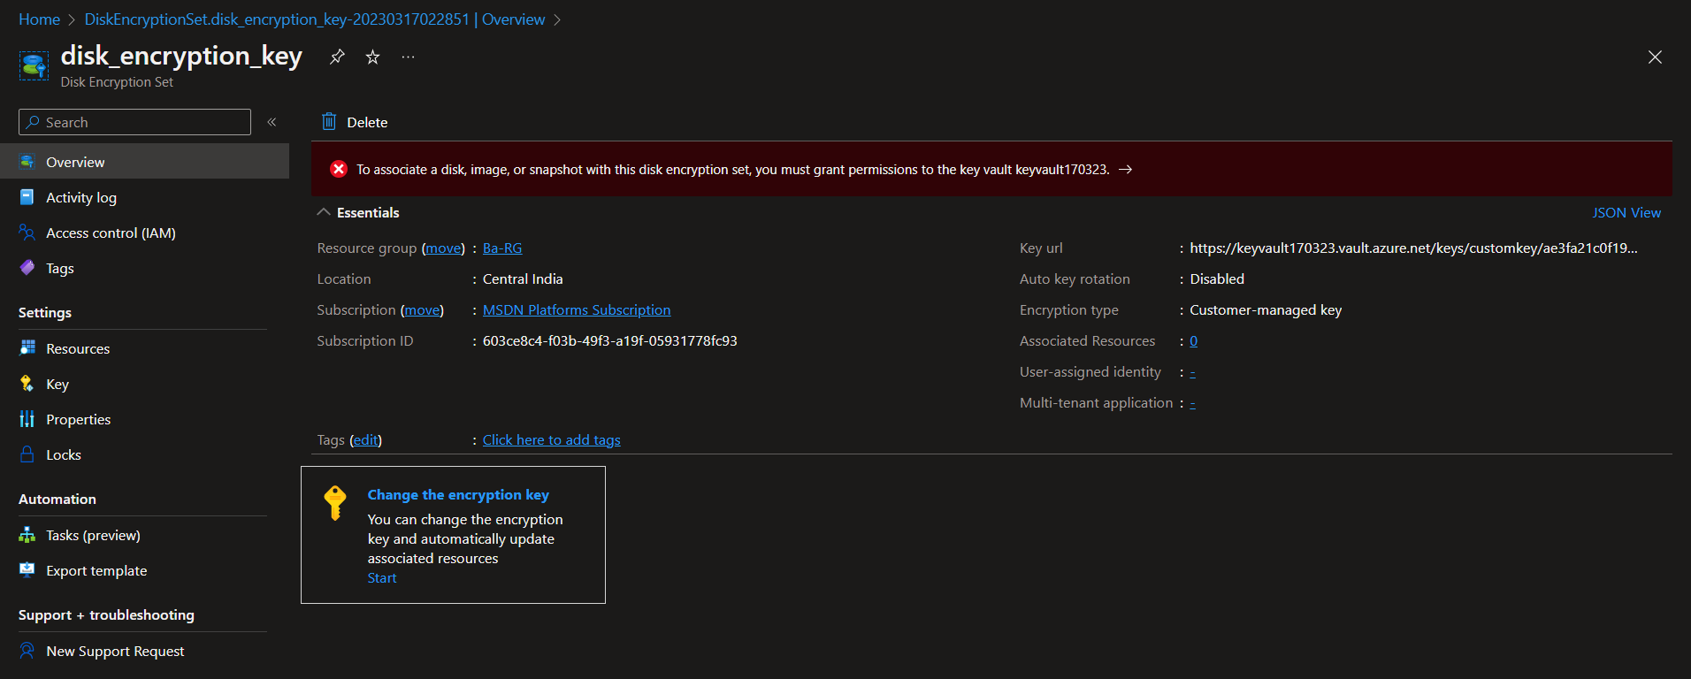

They grant the acess as per his required.

Step4 After that you have click on disk and click on encryption select your encryption and save it.

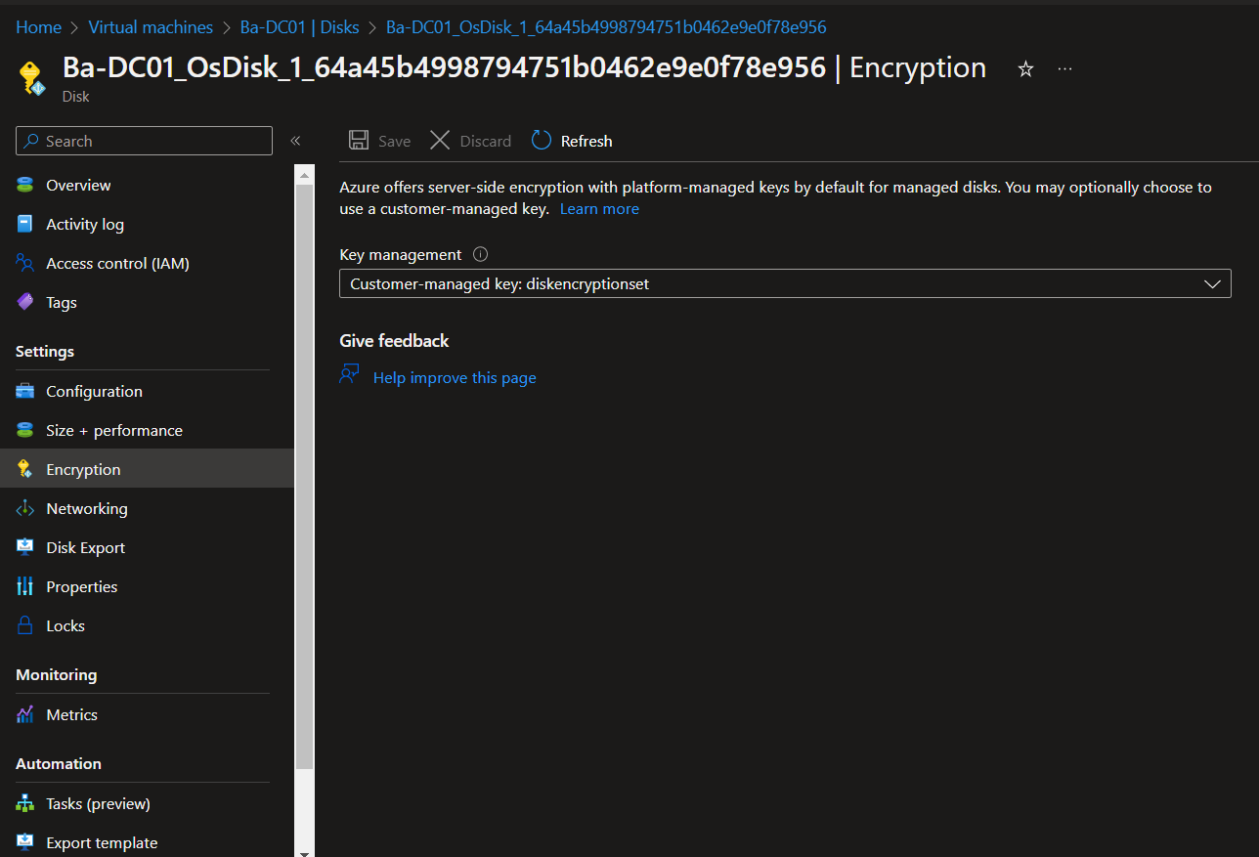

**Shared disk**

You can share the disk with multiple VM, In my subscription I can see that only standard SSD and Premimum SSD you are able to shared the disk. Standard HDD is not able to share the shared the disk.

If you attached disk you have to initialize the disk and create a new volum with the respective VM. And disk is shread but data is not visible for one VM to other VM.

Note – When you create the VM that time you have to attached the disk, after creation of VM you are able to attached any shared disk. If you shared your disk with multiple VM location must be same of the every VM.

**Custom Encryption Set**

First go to the visual studio code and type this script for the winodws IIS with extension .ps1

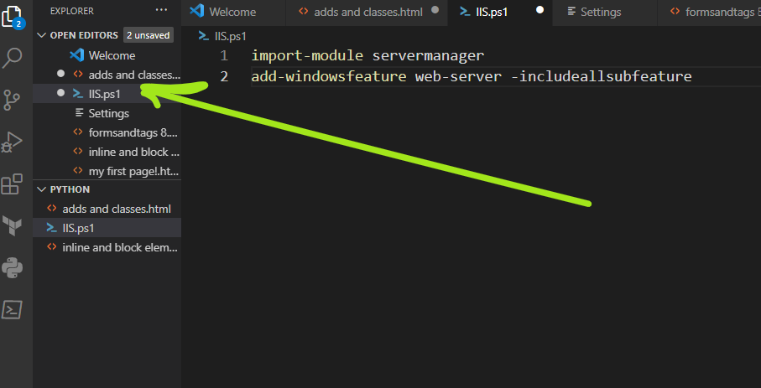

create storage account with default setting.

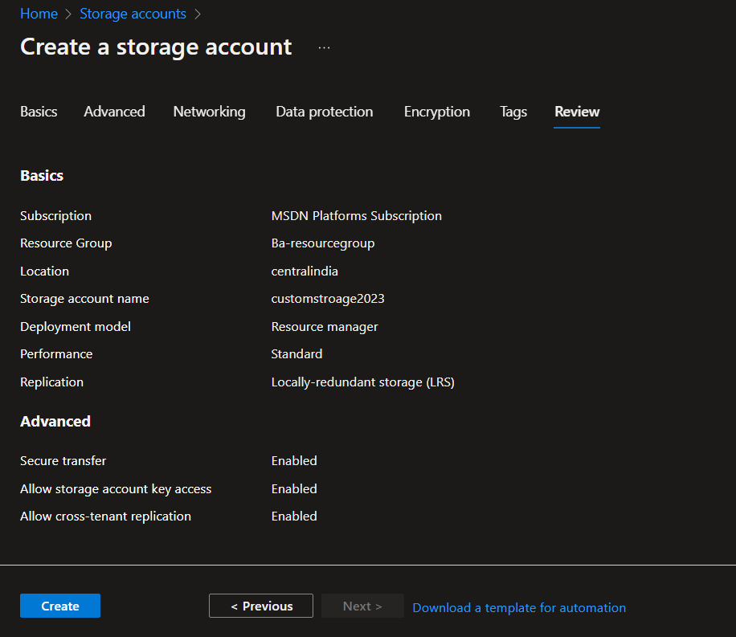

Once the storge account in place. Go to the container and create the new contrainer with name.

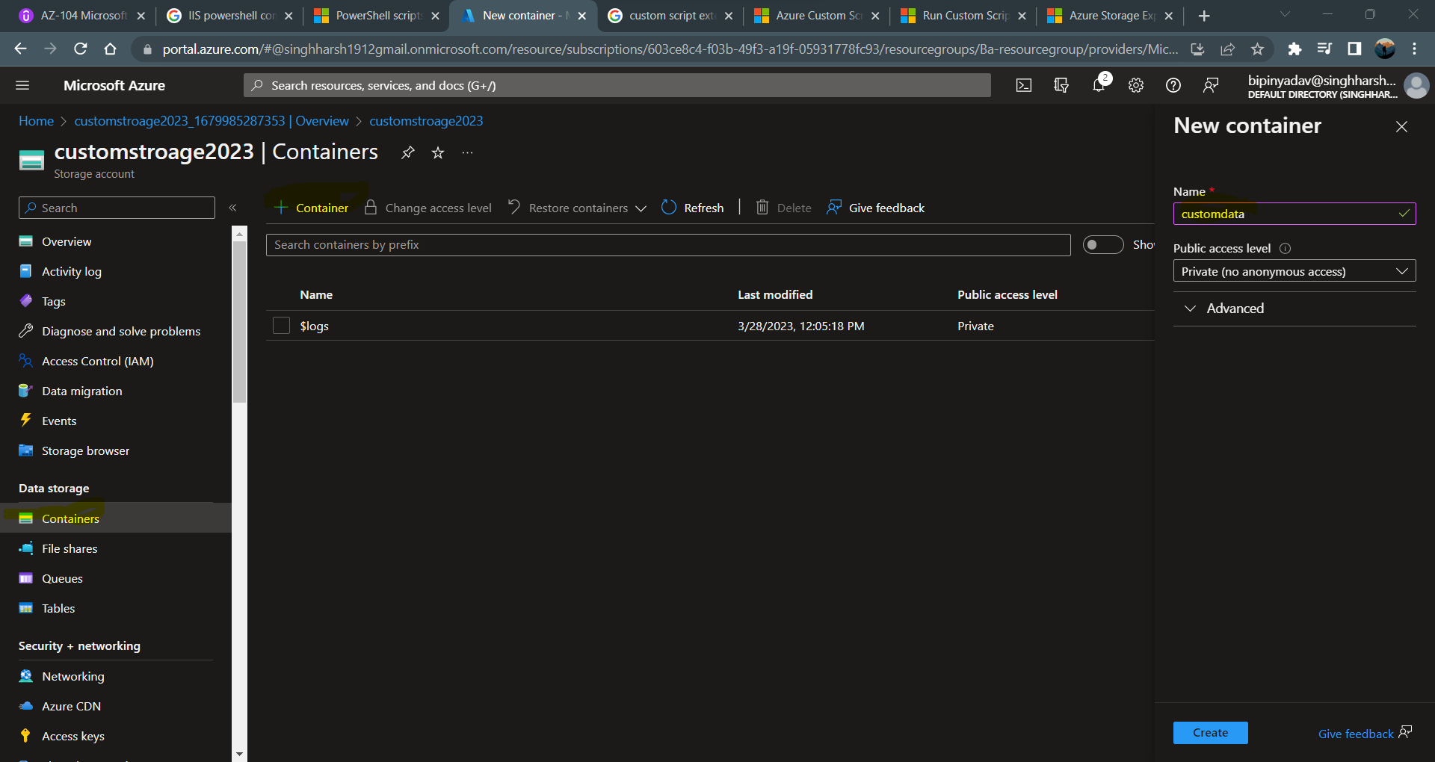

Once the container is created, click on the container and select the upload file and upload the powershell file (.ps1)

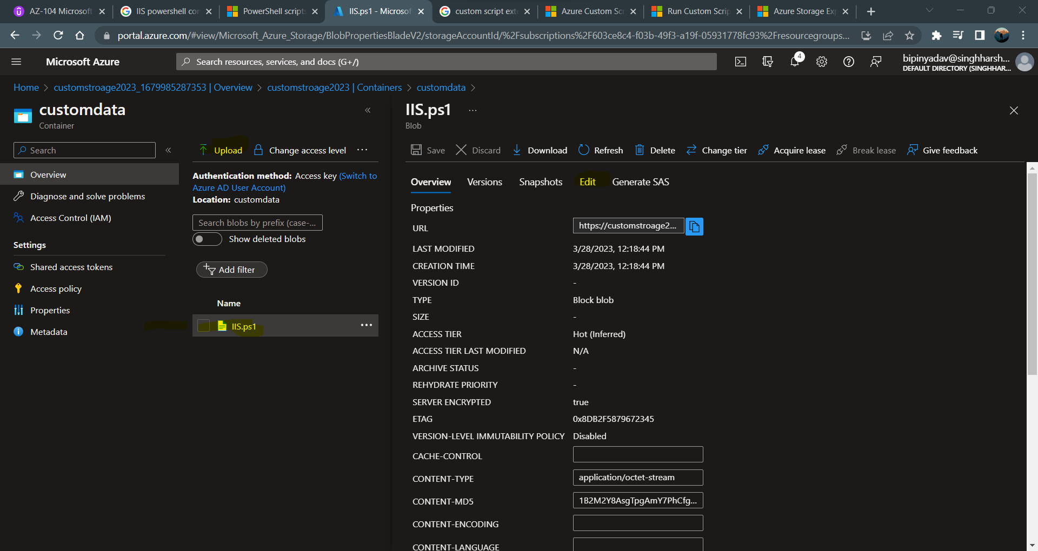

Create on VM and in advance you have to select custom extension and click on the that.

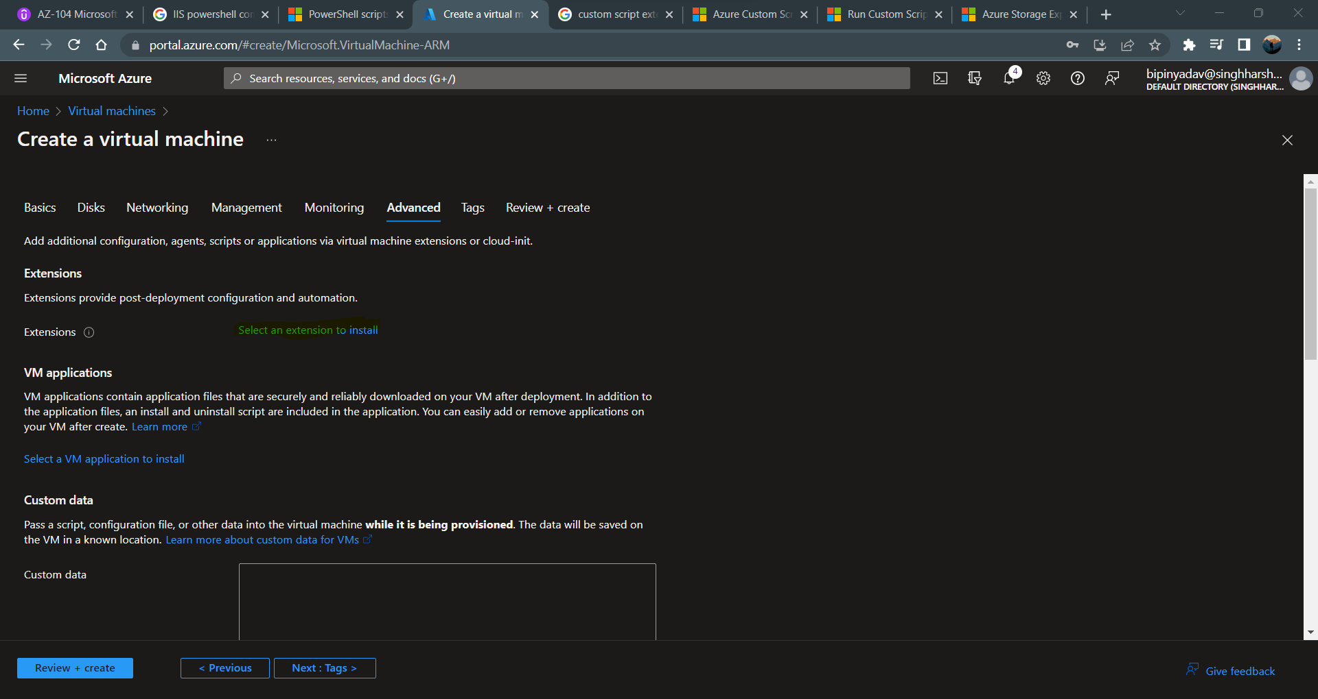

Search custom script extension and click on the next.

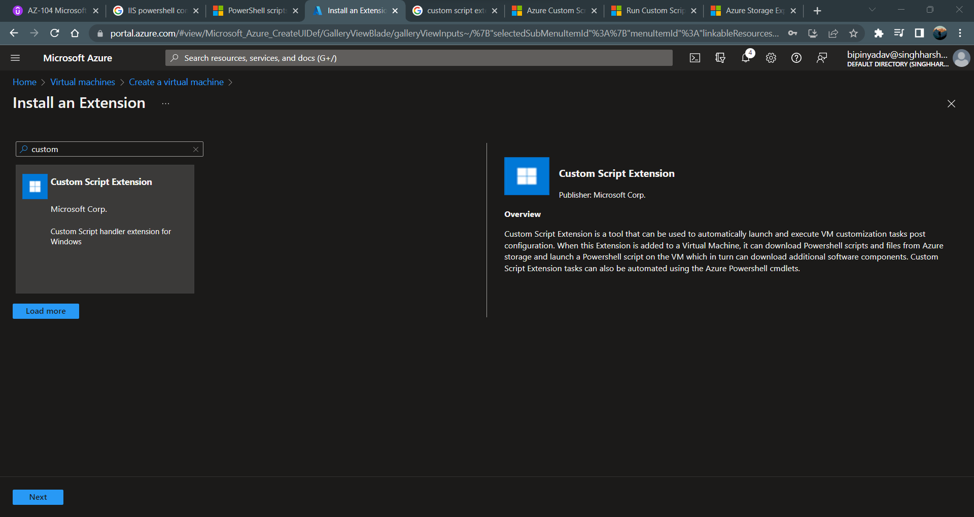

Select the storage account where your script is/are store

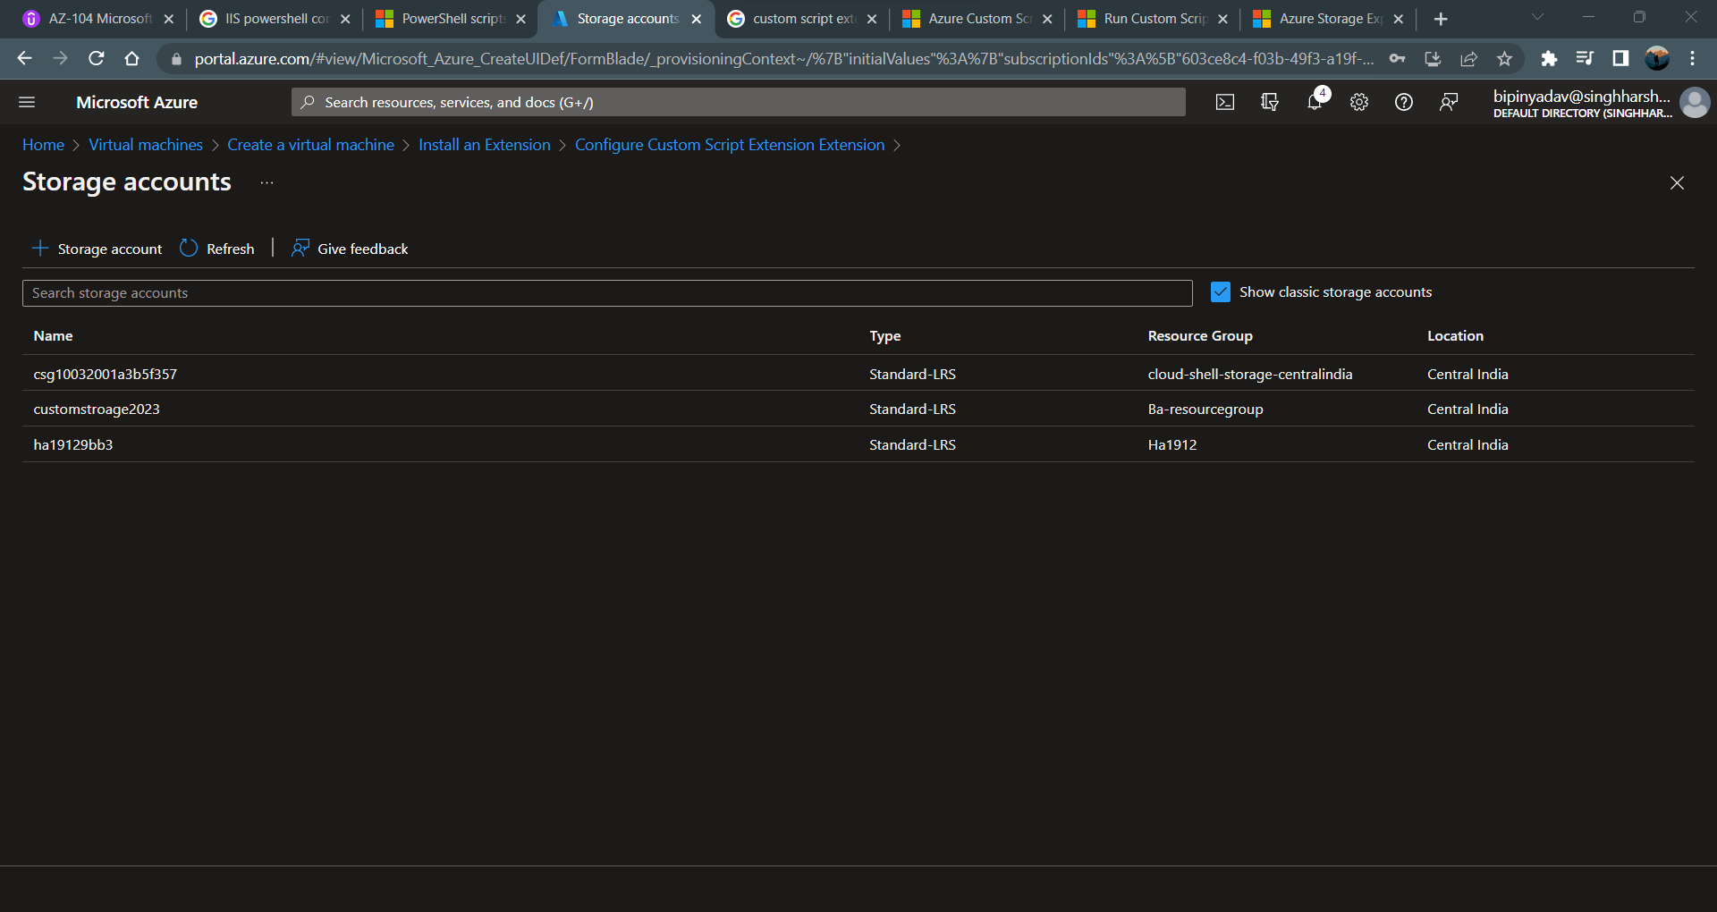

Create the vm and when VM is ready pickup the public IP address and past to the new tab you will see your web server on windows OS.

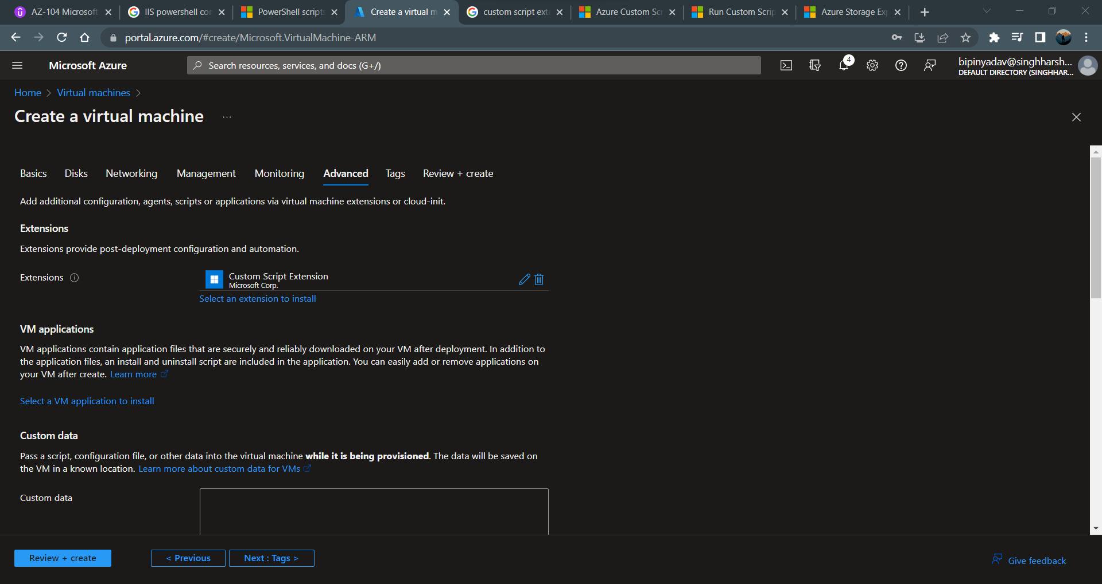

Click on the next review and create the vm.

After successfully deployment of the server, copy the public IP address and past Into the new tab and you can see your webserver is running.

Note – to run the webserver you have to enable the port 80 (HTTP) and secure connection webserver port 443 (HTTPS).

Everything is same except script.

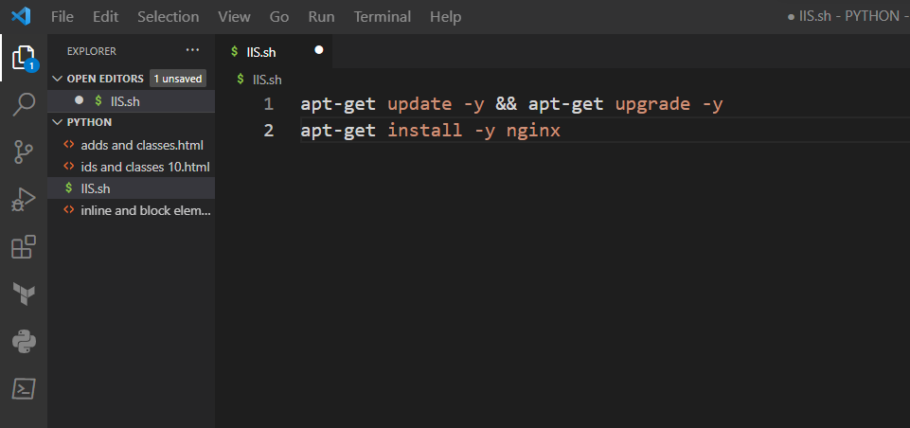

**Cloud init ( install the packeges of the linux base machine)**

You have YML file ( YML is again a markup language in which you can specify the cloud init)

If you want to install most popular package in the linux base server select this option cloud init for the fast move.

**#Cloud-config**

**Package_upgrade: true**

**Packages:**

* **Nginx**

You have to just copy all the script and past it on the cloud init box. Below is the example of the how I can do.

When you create the VM you have to come to the advance wizerd and type the given below command and click on the next and review and create the same.

Note – it take less time compare to the custom script because custom script required to install the agent and then run the script.

To show the webserver you have to copy the public IP address and past the new tab and see the result.

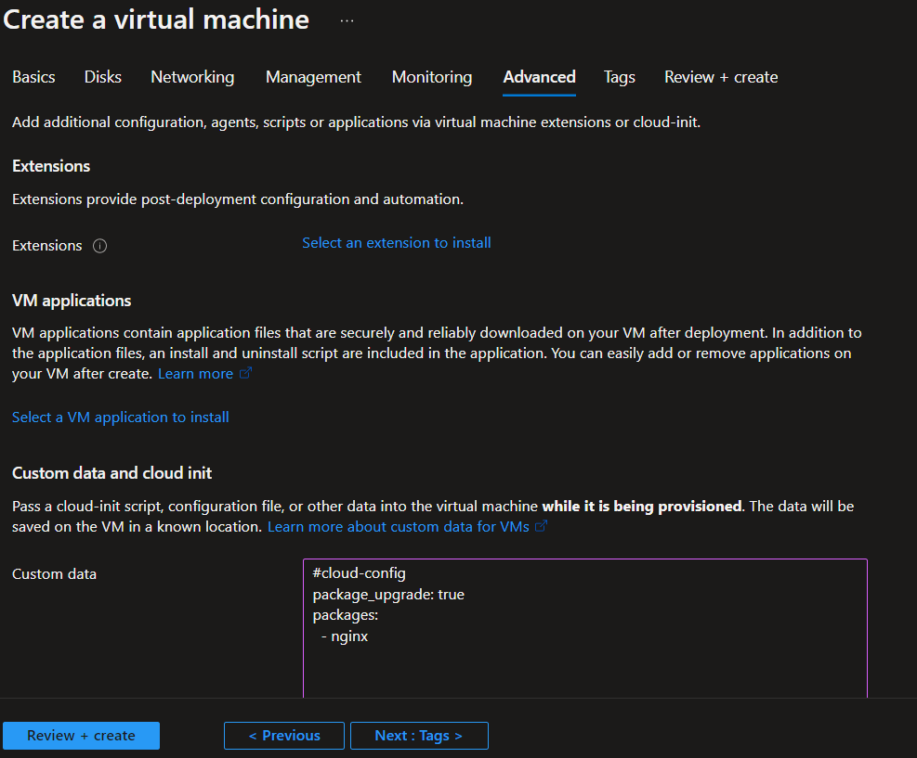

**Azure Bastion Service**

Fully managed PaaS service

Provide RDP/SSH connectivity to virtual machine from the azure portal via TLS ( transport layer secure portocal)

1. Azure Bastion service is for the privately connected with your server and don’t required public IP address
2. You can connect multiple server with the help of the azure bastion servcie and whether (windows / linux) in same virtual network (Vnet).
3. Connection via the internet on port 443.
4. When you create azure bastion servcie in your environment you have to keep one separate subnet called (AzureBastionSubnet) for allocating its resource that are required to connecting purpose.

Create on one VM without public IP address, when your server is deployed in your environment click on the connect and you can see the bastion option is showing for connection click on it.

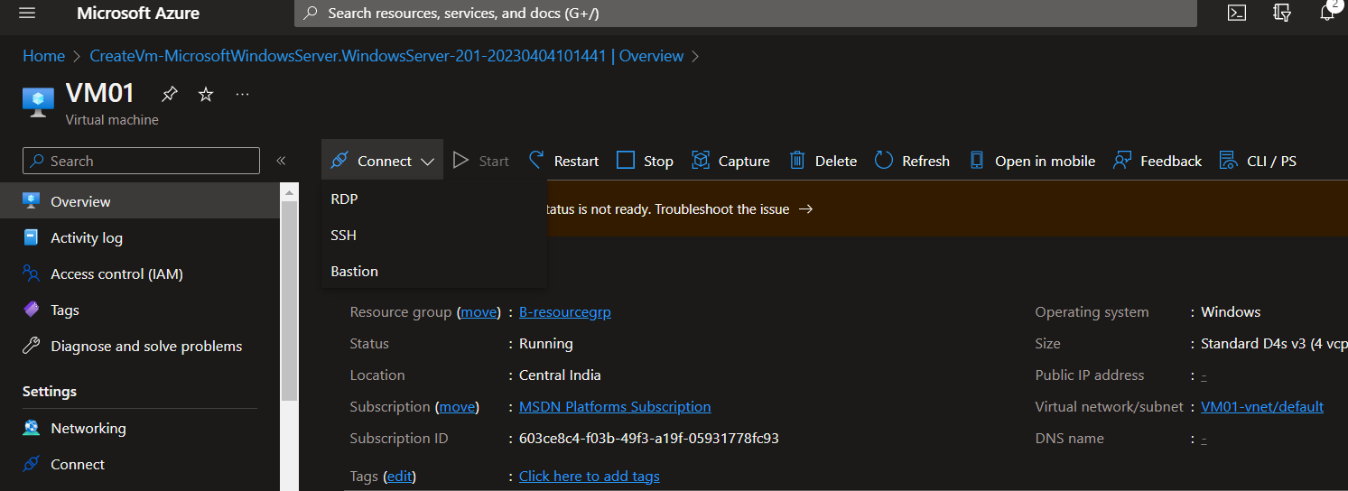

Click on the configuration manually

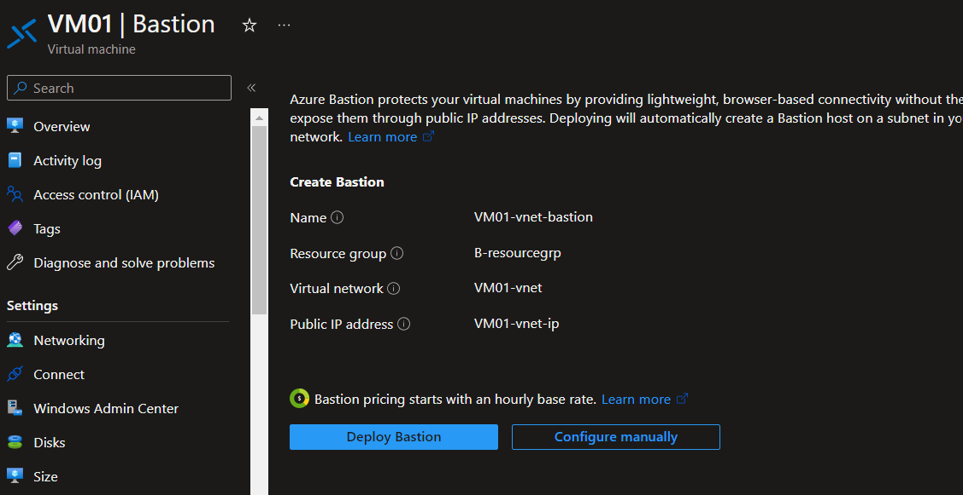

Fill the required data

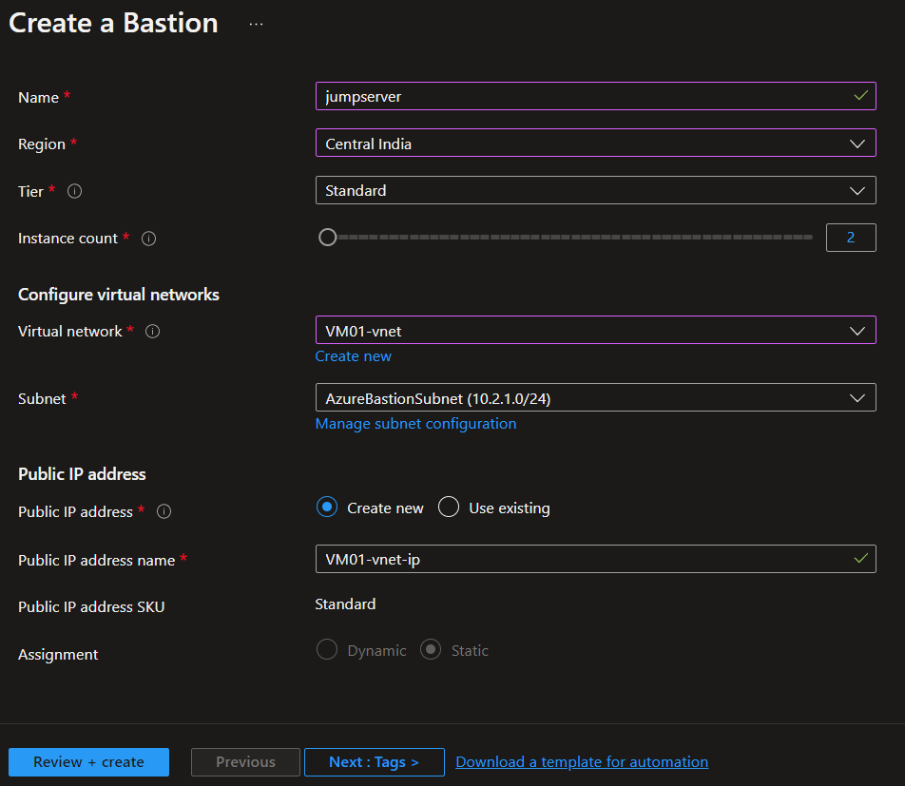

Click on review and create. Afte deployement click on the bastion enter the username and password and cick on connect.

**Availiabilty set**

Its just a feacture that provide you better up and running services

Definition- availability set is the logical group of the VM its help us to improve the entire availability of your application.

Update doamin- here azure will apply update to the physical infrastrcutre are update the domain at a time. You can have upto 20 update doamin.

Fault domain- here the virtual machine in fault domain and share the comman power source and networking switch. You can have upto 3 fault domain.

**Availability Zone**

There are physical location within the azure region these are made up one or more data center (DC), they have independent power cooling and network.

**Azure virtual machine scale set (VMSS).**

1. **Uniform orchistration mode**

Here the number of the virtual machine instance can be increase or decrease based on demand. These VM can be used for hosting your application.

Create virtual machine scale set and fill the all the required data under the networking wizard edit network interface (NIC).

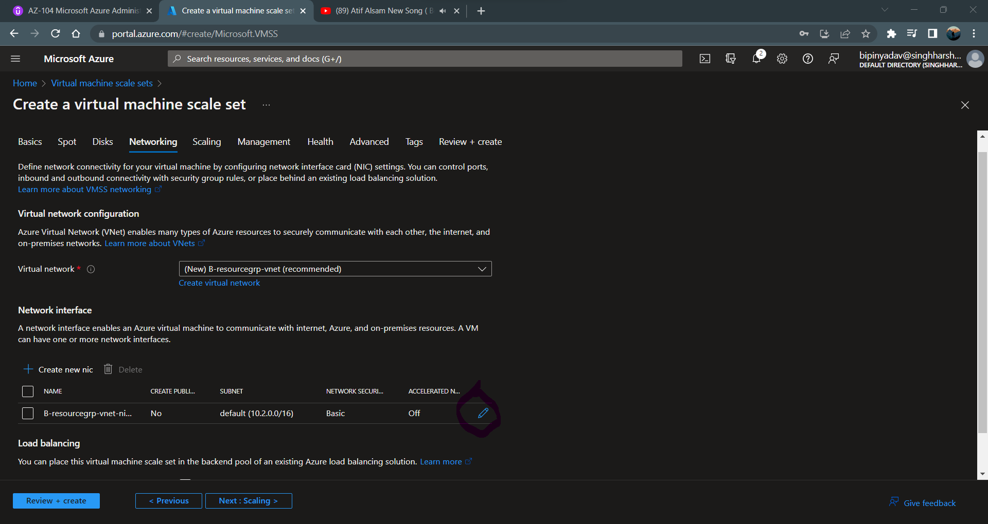

Allow inbound ports and enbale public IP as well click on ok.

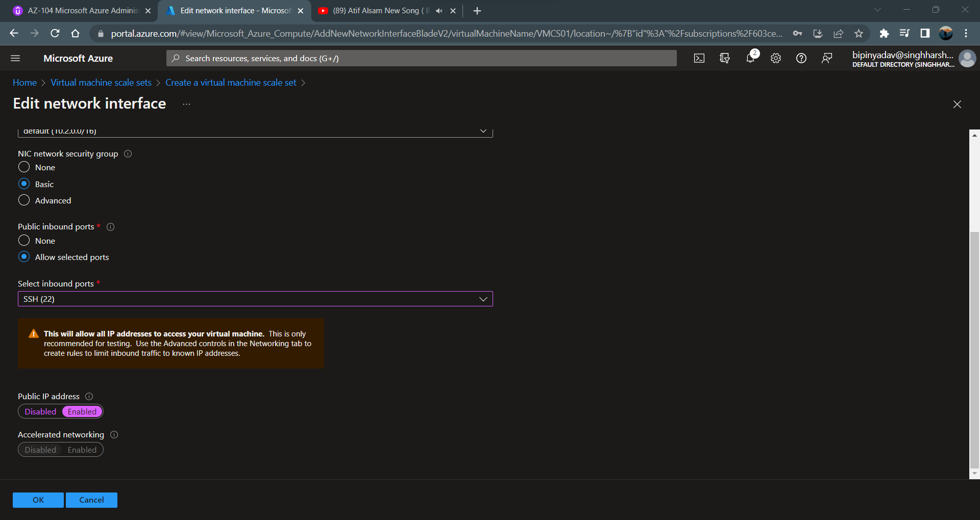

Rest keep everything as it, and review and create the virtual machine scale set.

Note- After deployment of the VMSS you can seen under RG no public IP & VM is show because they manage internally itself.

Only you can see the Vnet, VMCS, NIC is showing.

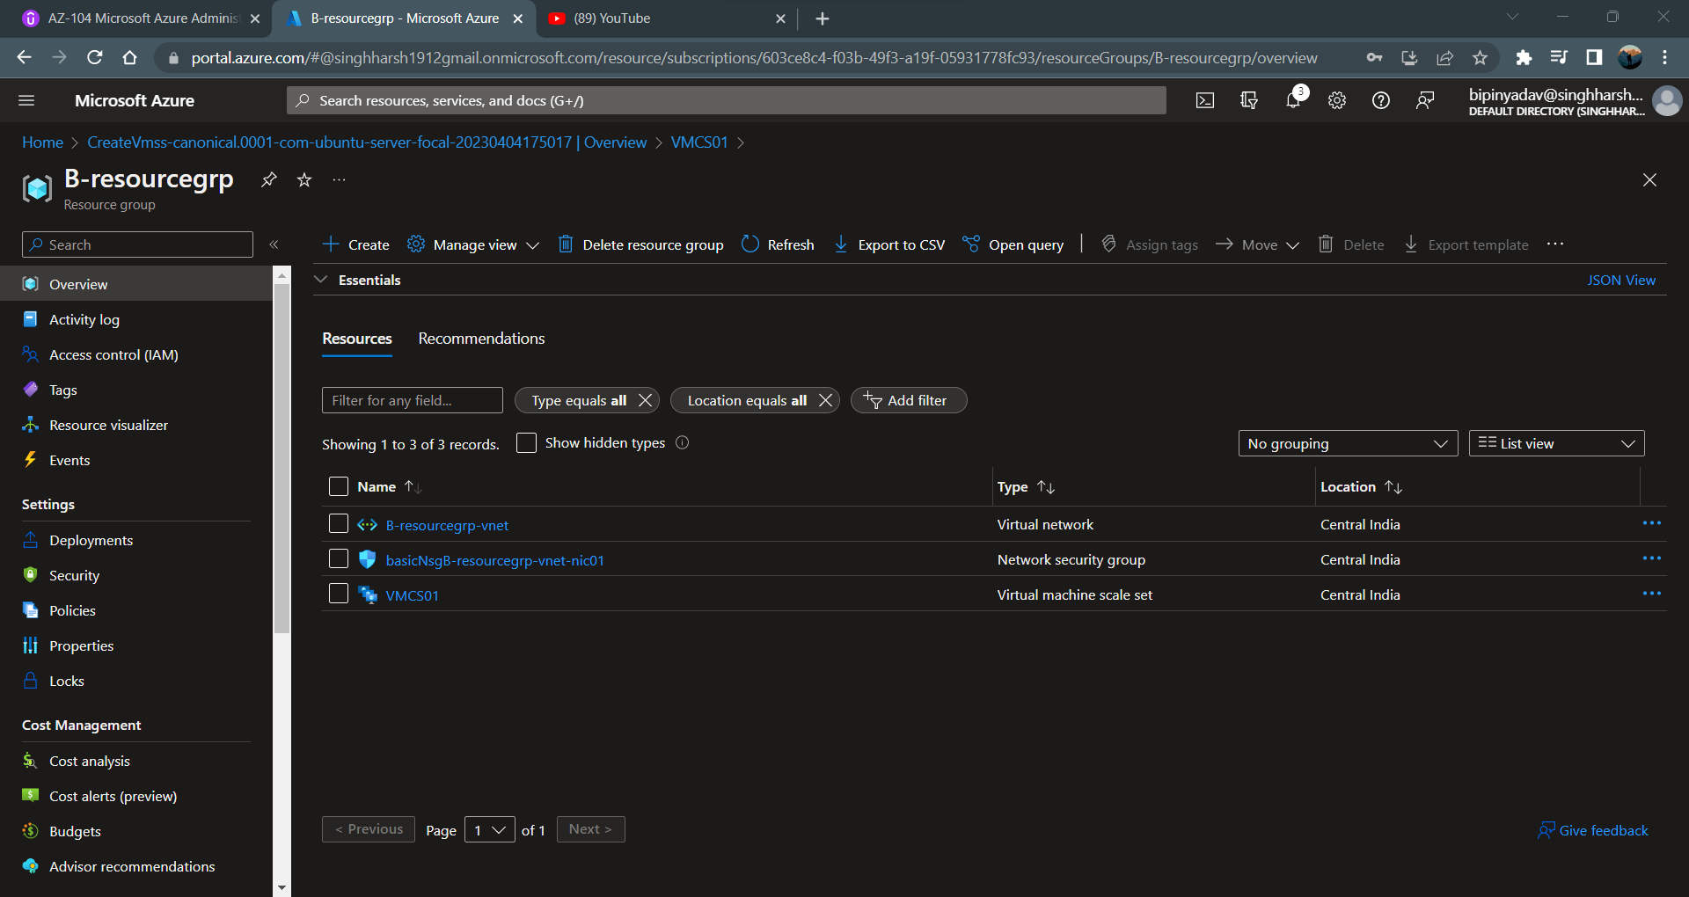

If you want to see the public IP address click on the instance and you will see.

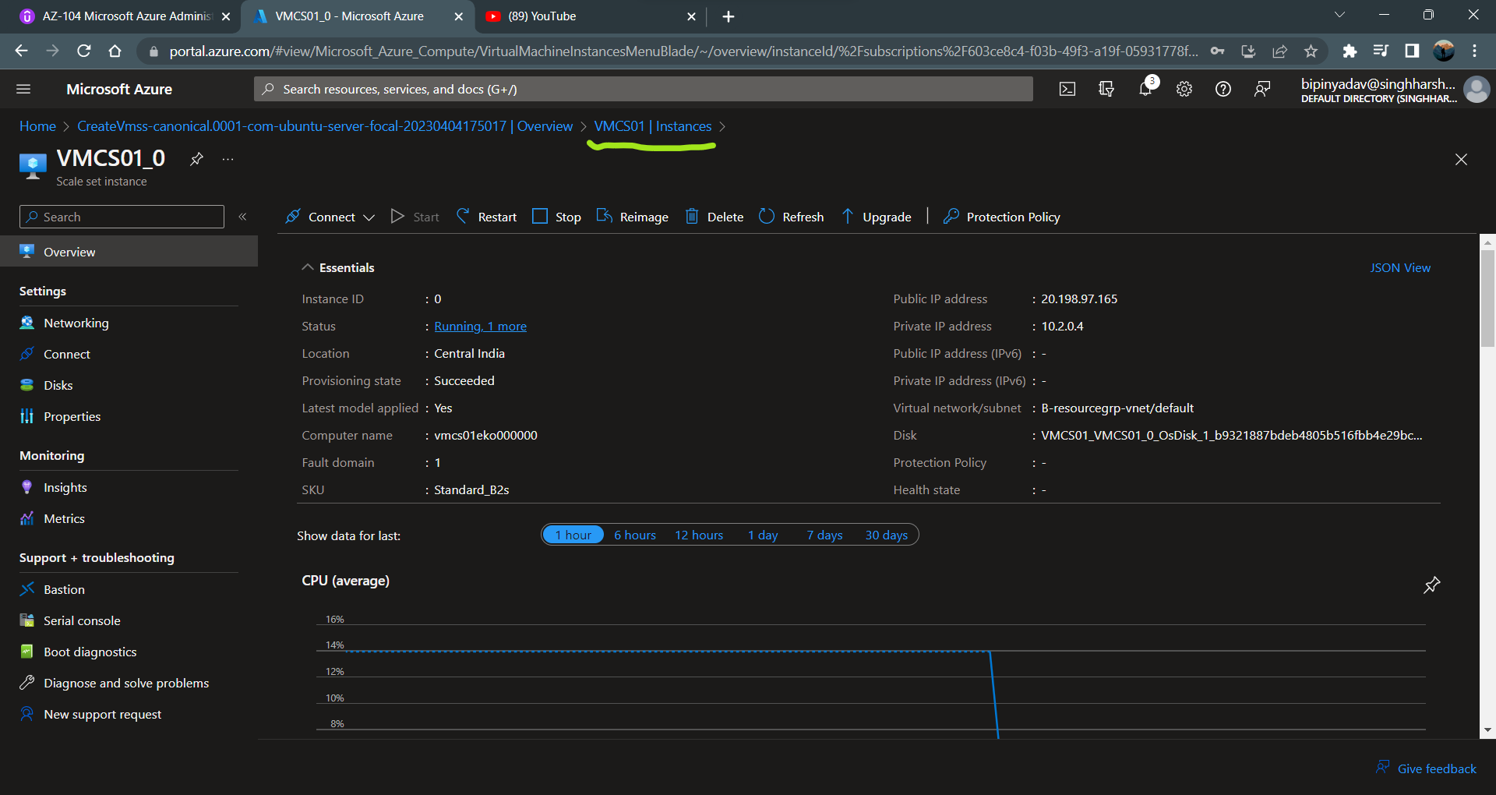

In the manual scale count you can just increase and descres the instance count.

But in the custom autoscale you have to configure the details.

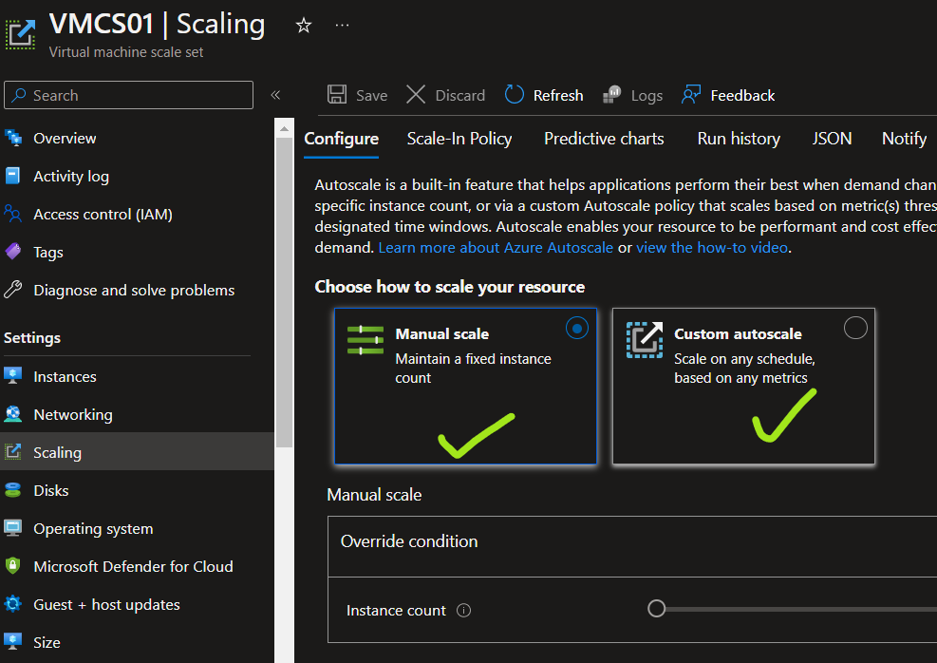

Select the custom autoscale and fill the required details.

Select the instance limit and click on the add a rule.

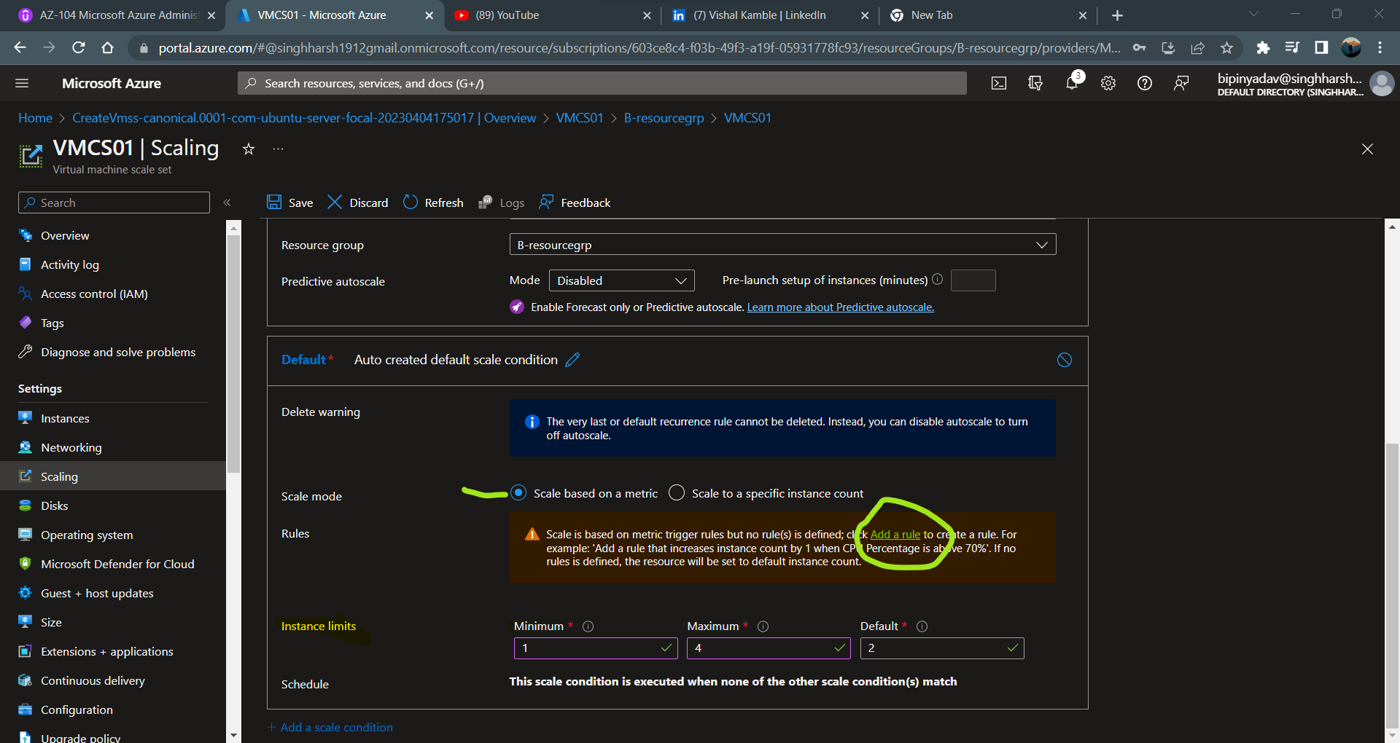

After click on the add a rule we have to set the rule scale out and scale in rule.

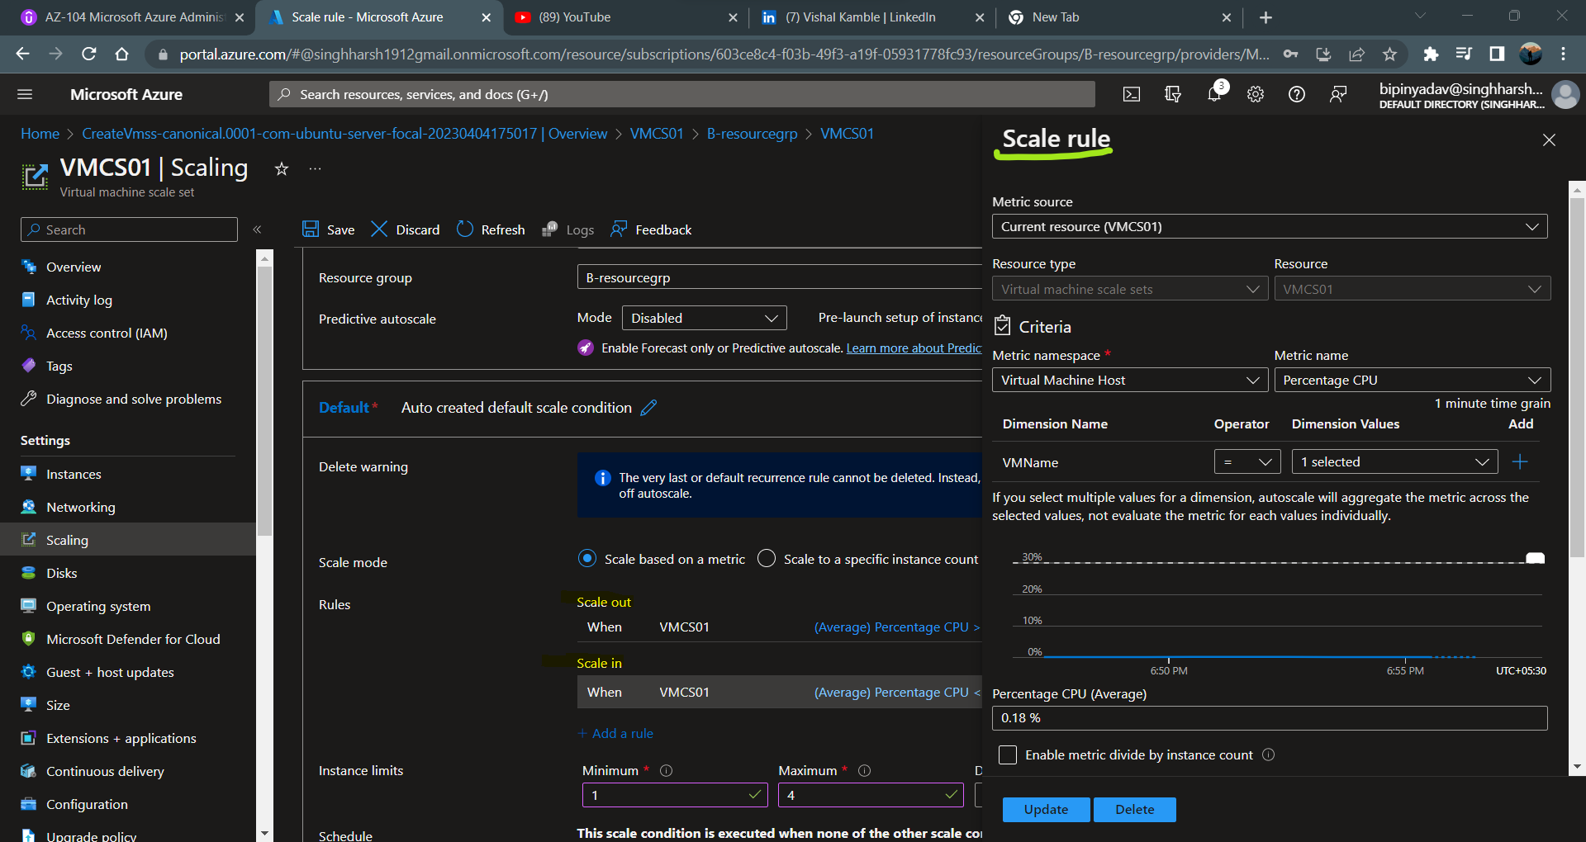

for testing which server you selected for the CPU %, take public IP login with credentional.

Right Im in linux server

Sudo apt-get update

Sudo apt-get install stress

Sudo stress – cpu 100 (this is the artificial stress)

1. **Flexible orchitestration mode**

Flexible orchistration mode is just like a normal VM all the other component show like other VM. You can also add the new virtual machine scale set

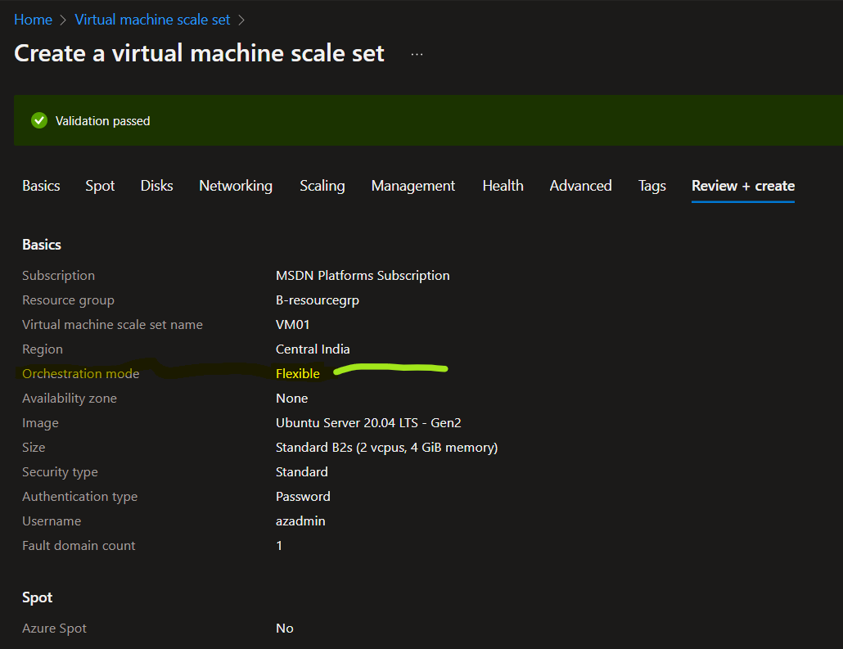

When you create the normal VM to add the virtual machine scale set.

You can not add the existing vm to the virtial machine scale set.

You can install the webserver application with the help of the custom script and under run command in side the powershell script.

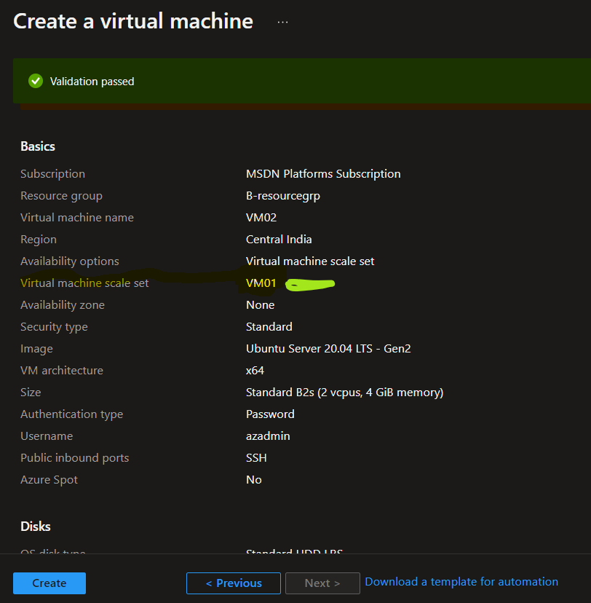

**IMAGES**

**Images –** this is the copy of the full VM which include the data disk or just in os disk.

You can create the image and place the part of the azure compute gallery.

You can share the compute gallery across the organization so, that other user can create the VM based on images stored in the gallery.

**Image definition** – this is the grouping of the image version. Each image definition has information why the image is created and other information related to image.

**Image version –** are used to create the VM.

**Two type of images you can create**

1. **Specialized VM image -** here the information about specific user and machine information is retained.

When new vm is created out of the image will have the same computer name and admin user information.

Steps - create one VM go to the overview part and click on the capture.

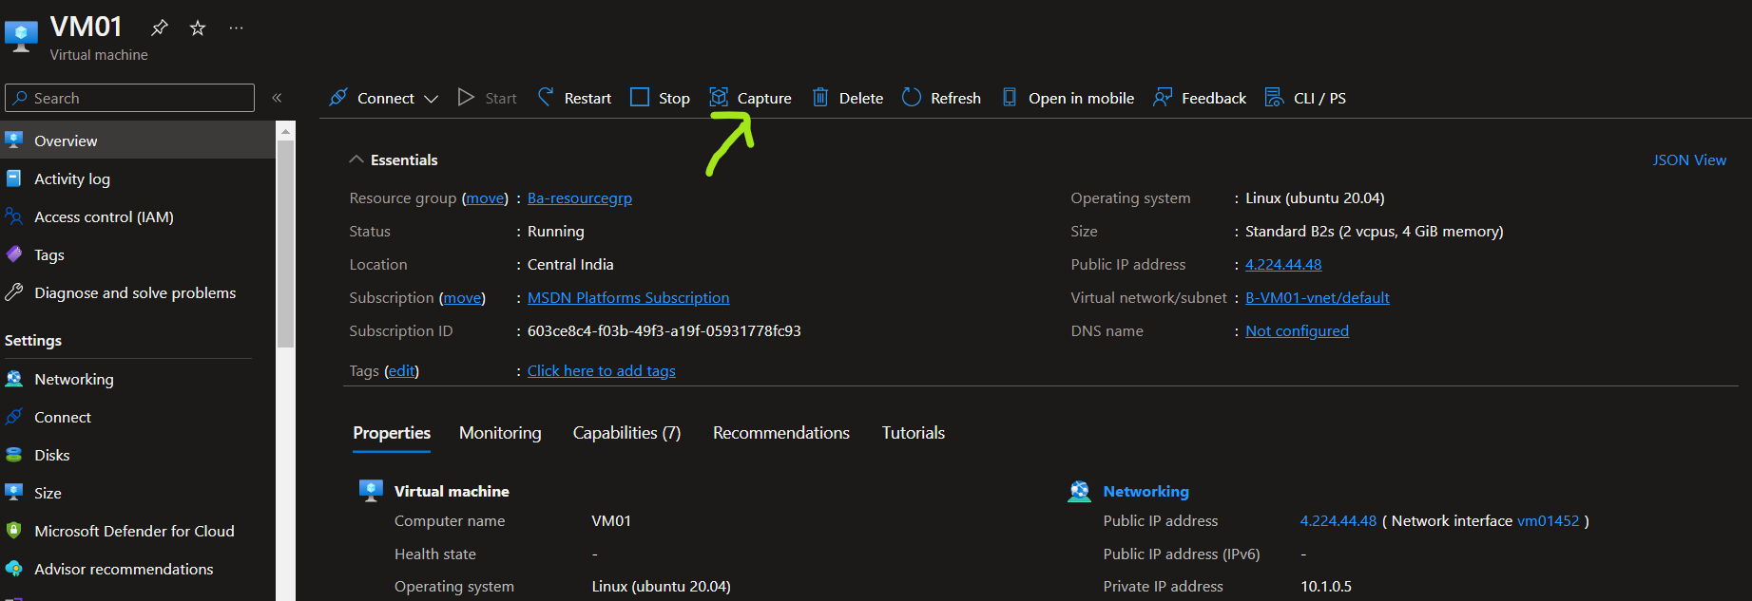

When you click on the capture you will see the below mentioned formate

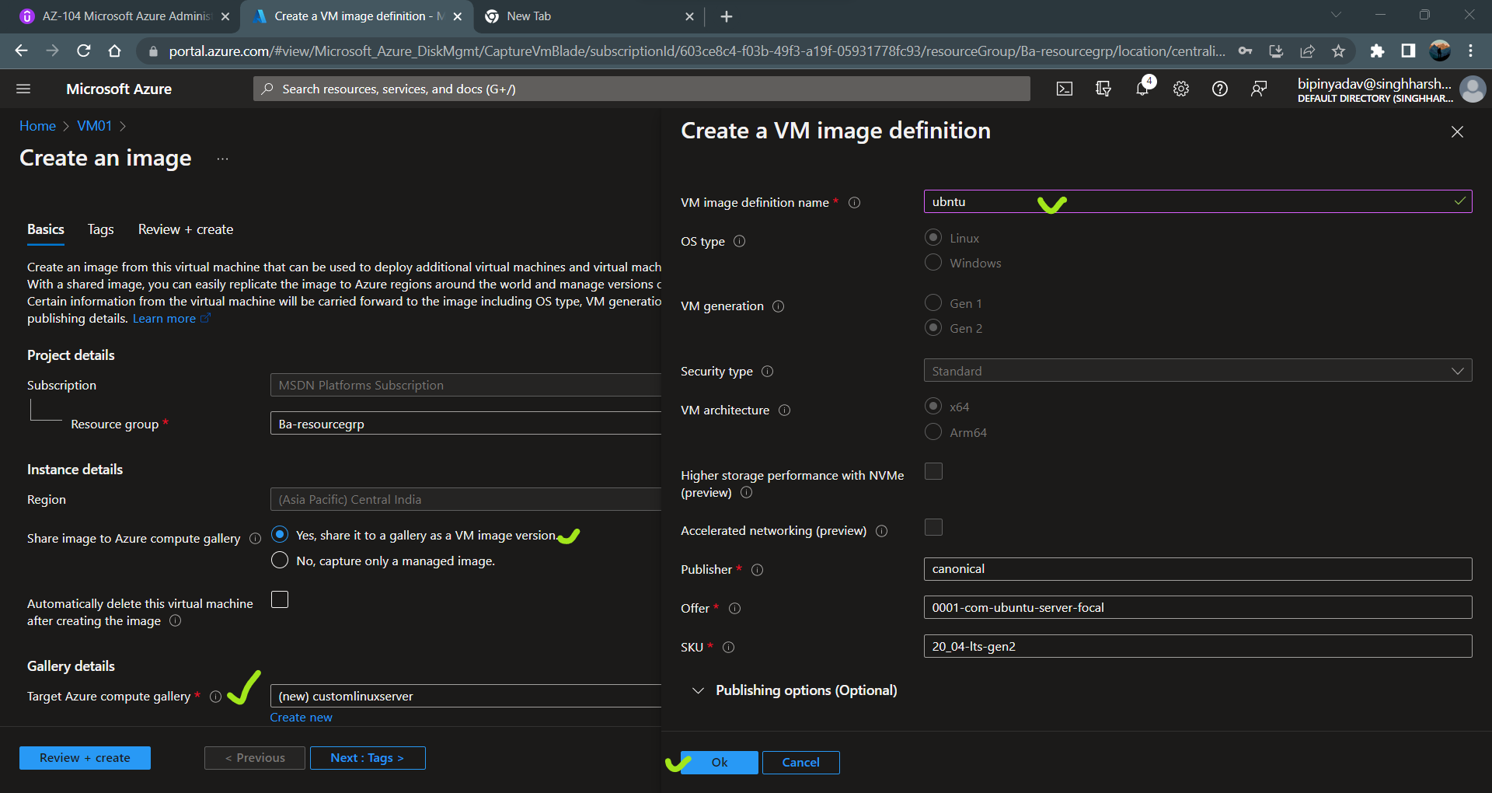

Click on the ok.

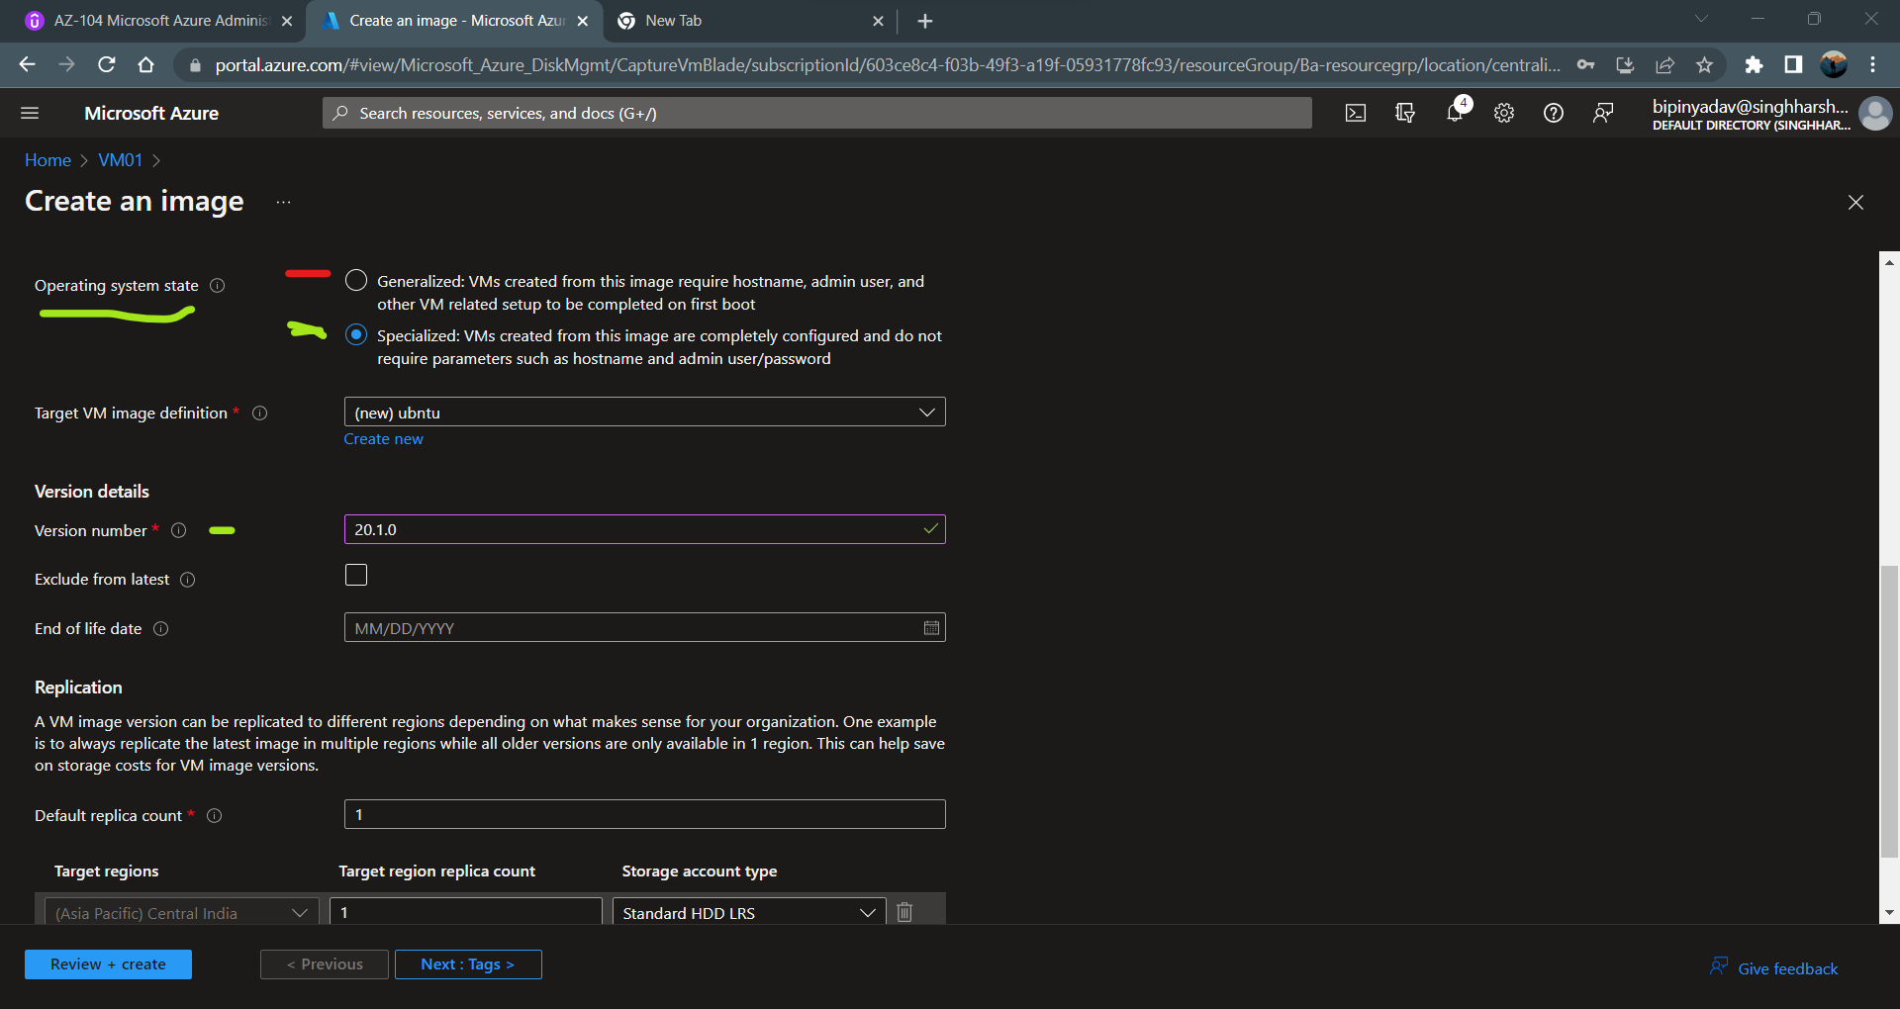

**Note** – when you create the image root VM first stop and then image deployment process is start.

Click on the Create the new VM

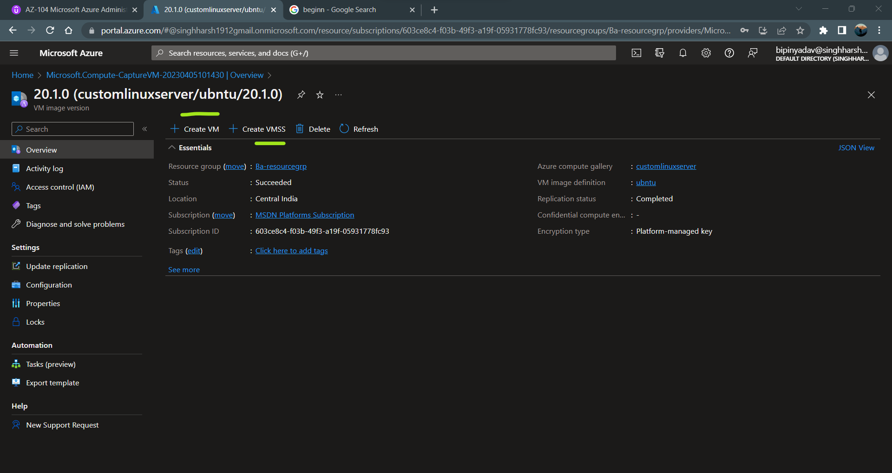

They pick up the image automatically and not need to put the username and password.

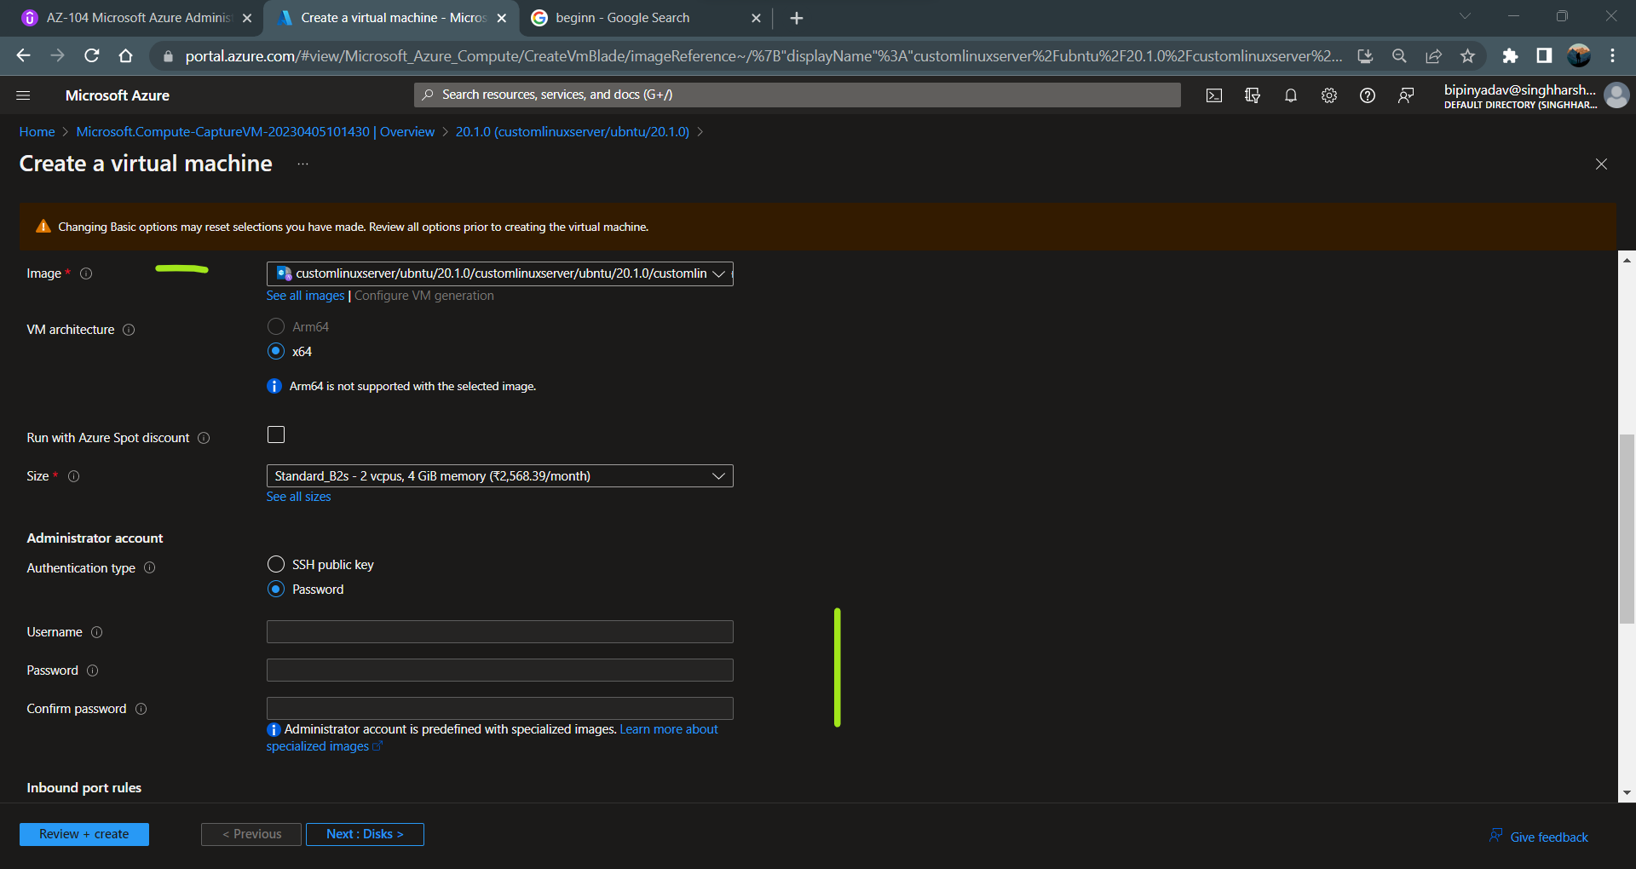

1. **Generalized VM image –** here the information about the specific user and machine infroamtion is removed.

Here you have to perform the process of the generalization the original vm is unusable after you perform this process.

Steps – in the generalized VM once you capture the image the VM in not useable for any thing

You can not start the VM again.

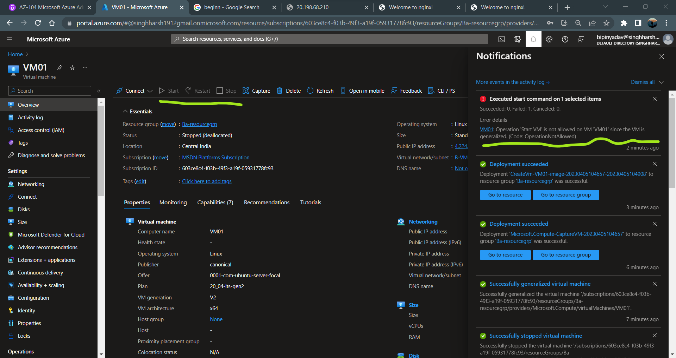

After deployment of the vm you can see that error we are facing but when I see the VM status VM is running state and showing this error.

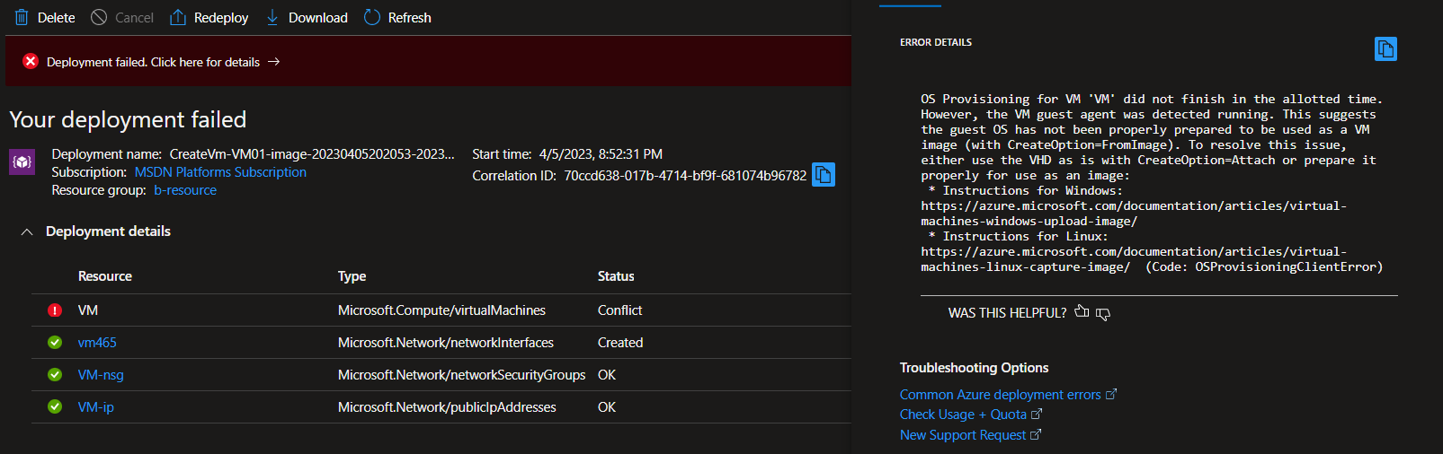

**Create Proximity Group**

When you create the virtual machine they are hosted in some short of physical server.

Proximity placement group are used for the least letency for the application whether they have same physical location or across physical location.

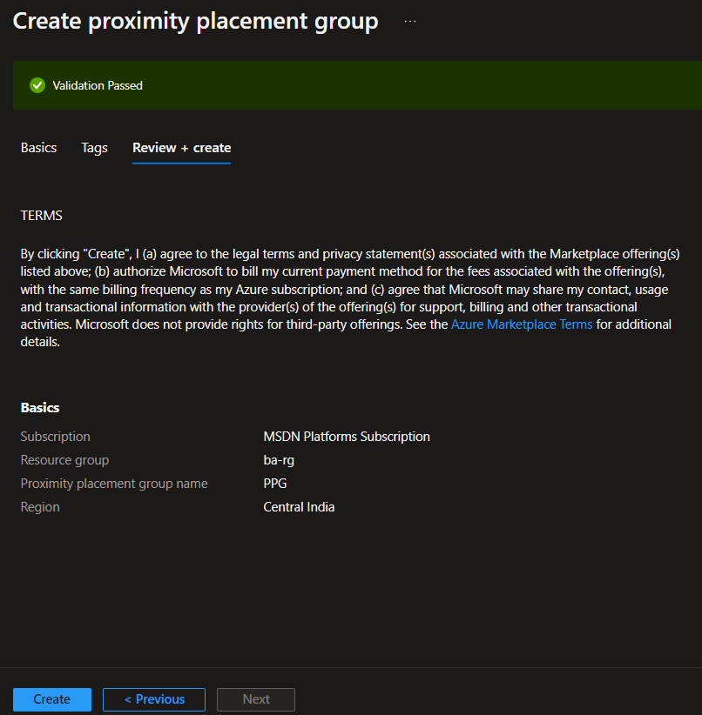

Under the advance wizard you can see the proximity placement group.

Note - you can not used it for the different location. Proximity used for the same location with least latency.

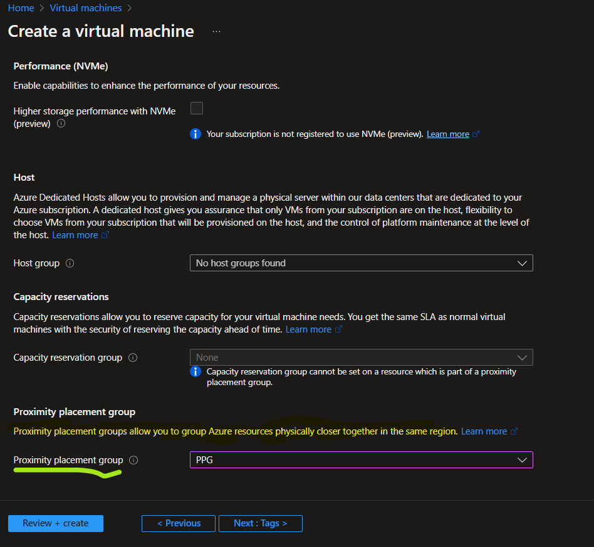

**Azure Web App / App Service.**

In the development phase developer do the code and on the deployment phase we need to install the webserver to host your webapp.

You can deploy your web servcie on Azure App servcie (PaaS) manage all the azure itself.

Azure App service are also scale up and scale down based on demand.

**Azure App Service Plan** – is define the set of compute resources and feacture that will we assign to azure web app.

Azure (web app / App service) linked on Azure service plan based on the service the compute infrastructure would be allocated on to the underlying azure web app.

**Note** – Application insight is the performance monitoring tool that are present by in web app and you have the ability to enable or not.

You, can host multiple web application in the same App service plan (ASP)

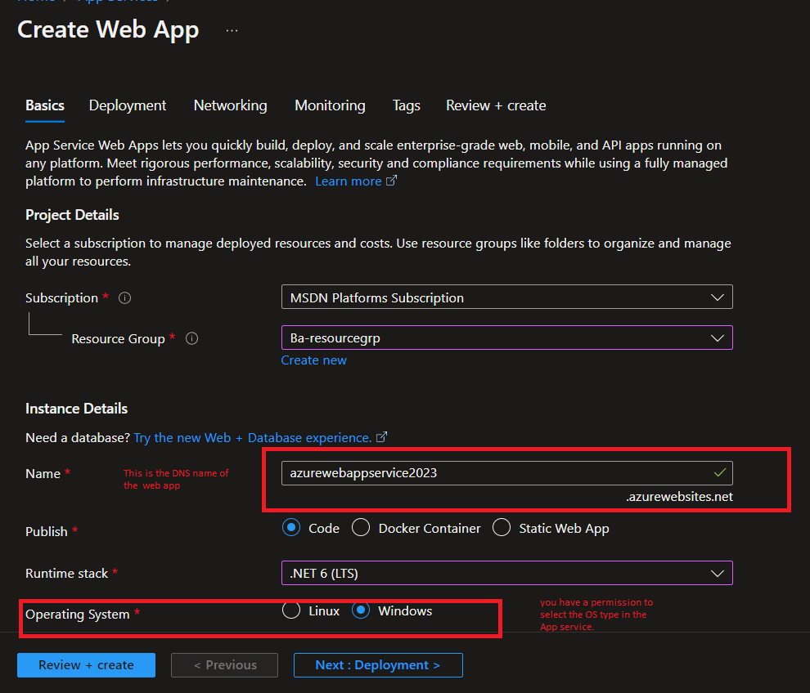

They automatically created default App service plan (ASP) for you as well as pricing plan. But you have a ability to change the ASP name and pricing plan.

**Note**- App service run 60 minute per day on compute. If you have more than one app service you will divide the 60 minute to perticular web app.

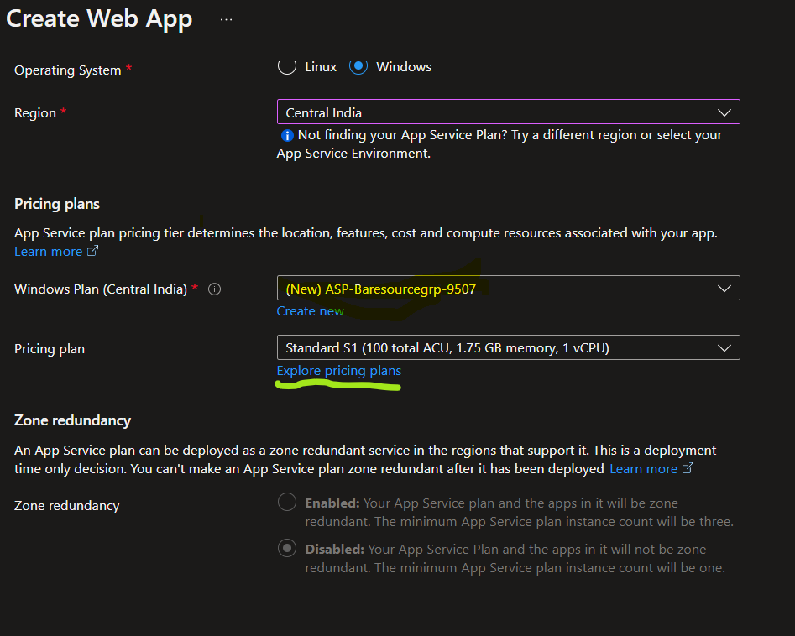

On the left hand side click on the app service editor

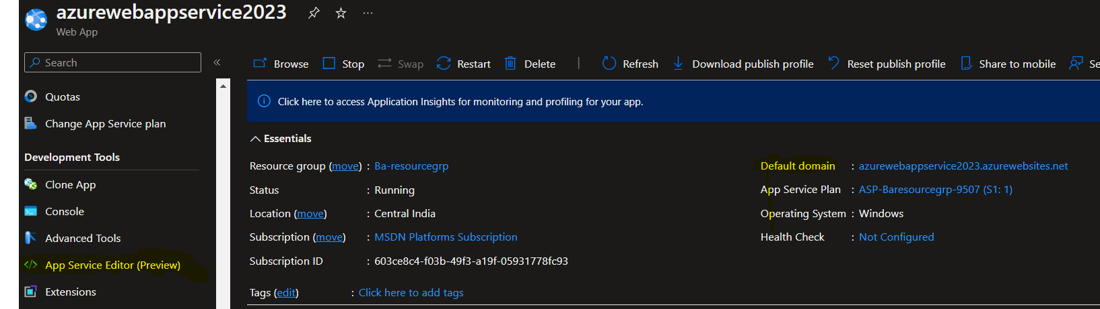

Click on the open editior, new tab is open.

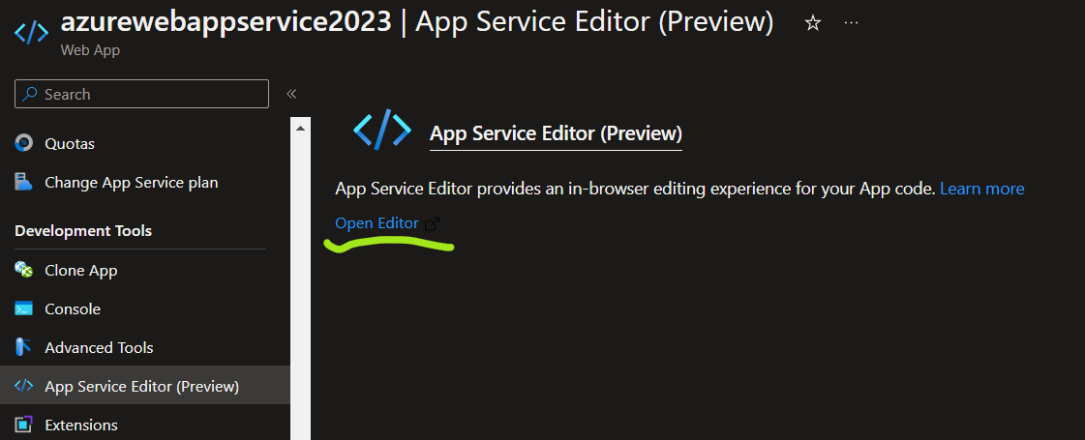

Create file with .html and type your code they automatically saved your code click on the url / DNS link to view your output.

You can also run your code click on the run button.

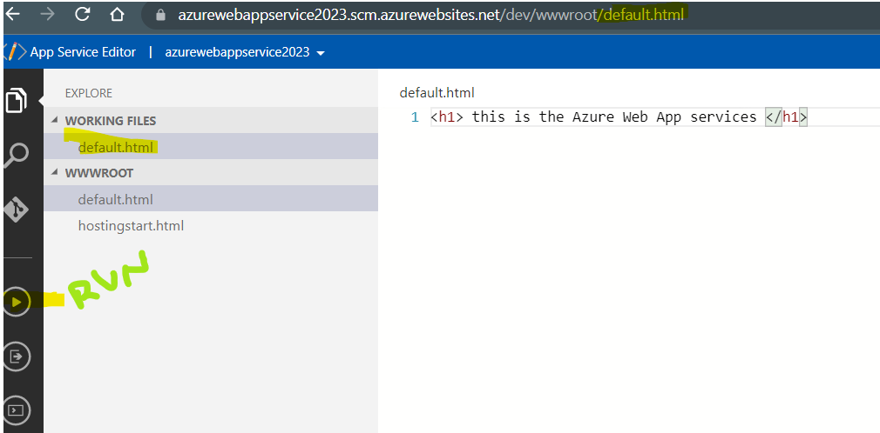

**Note** – you woun’t have permission to login to your server and create the .html page. Because all the resource manage azure platform as a service (PaaS).

How to publish your .net code /python code in your local system to azure web App itself. First download the visual studio 2022 and create new project and search on the asp.net web app click on the next.

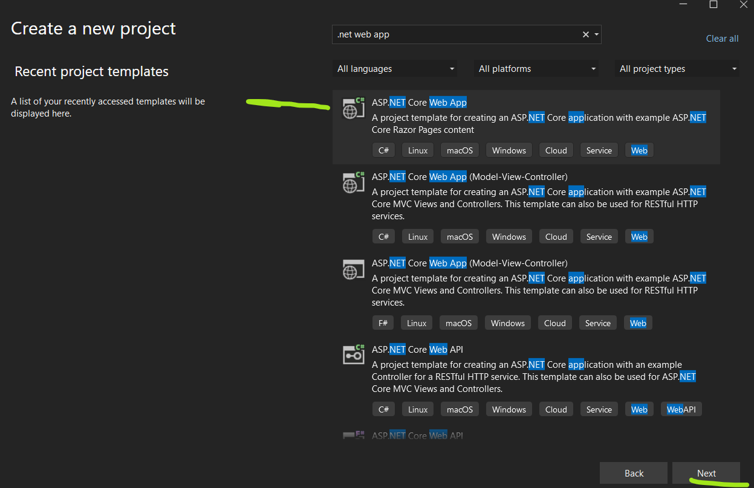

We need to link visual studio 2022 to Azure account.

Click on the tools select the option and on serach bar type azure click on the Azure service authentication enter your Azure portal credentionl click on next.

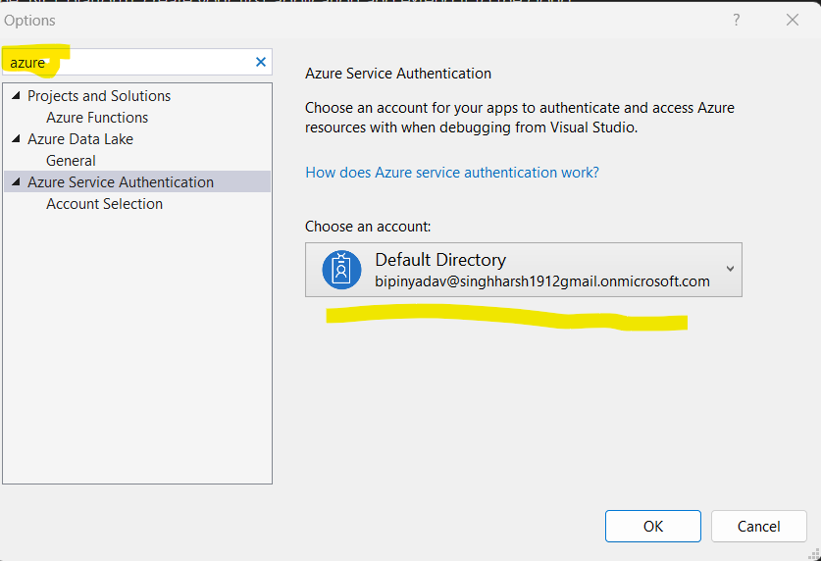

Go to your project right click publish on your project.

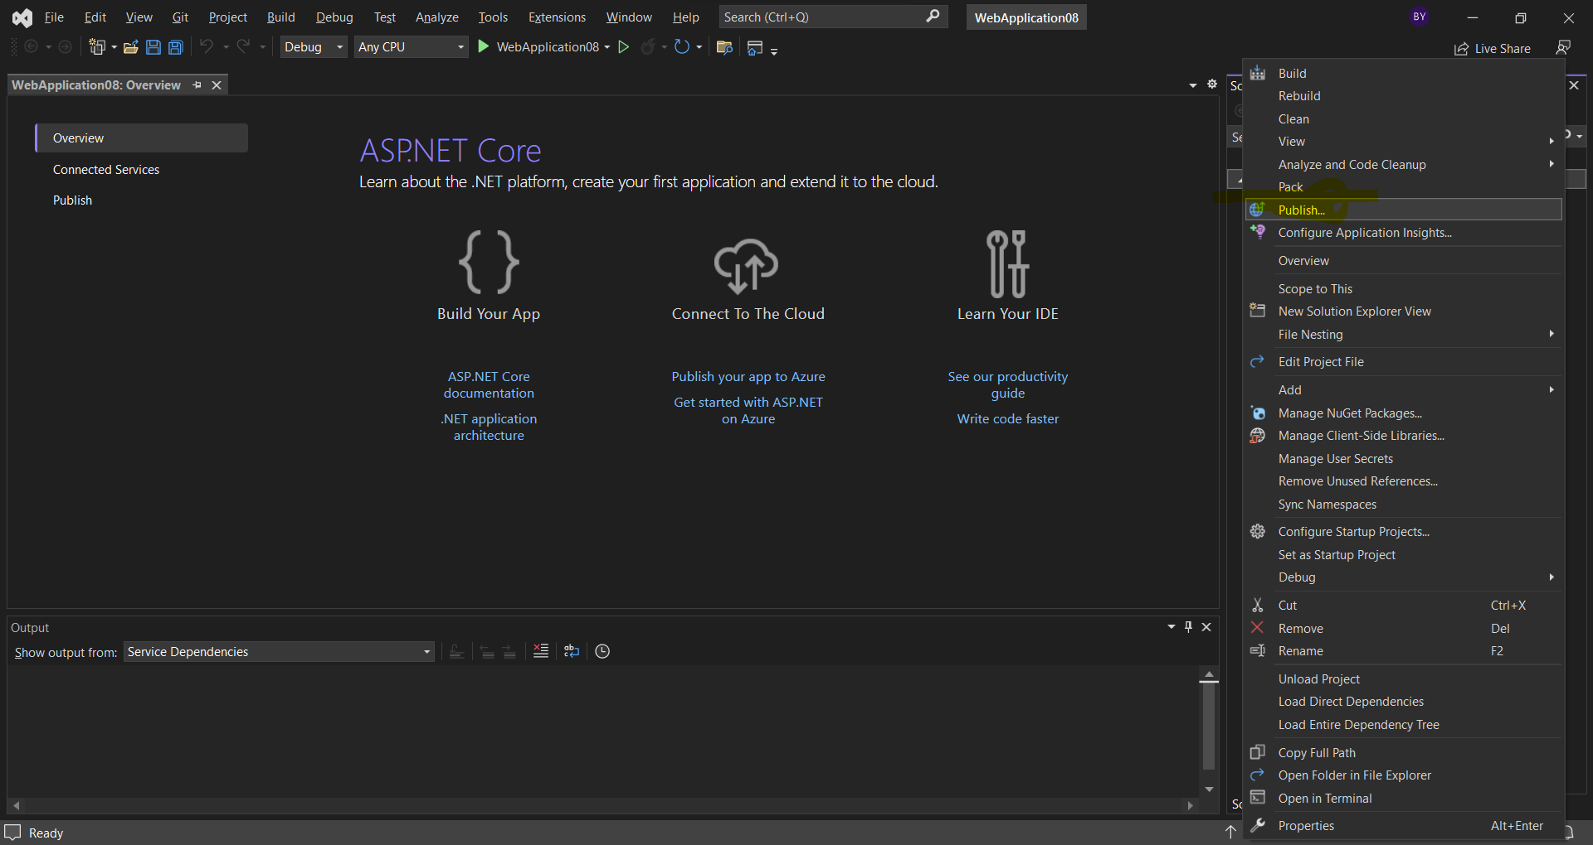

Select Azure and click on the next.

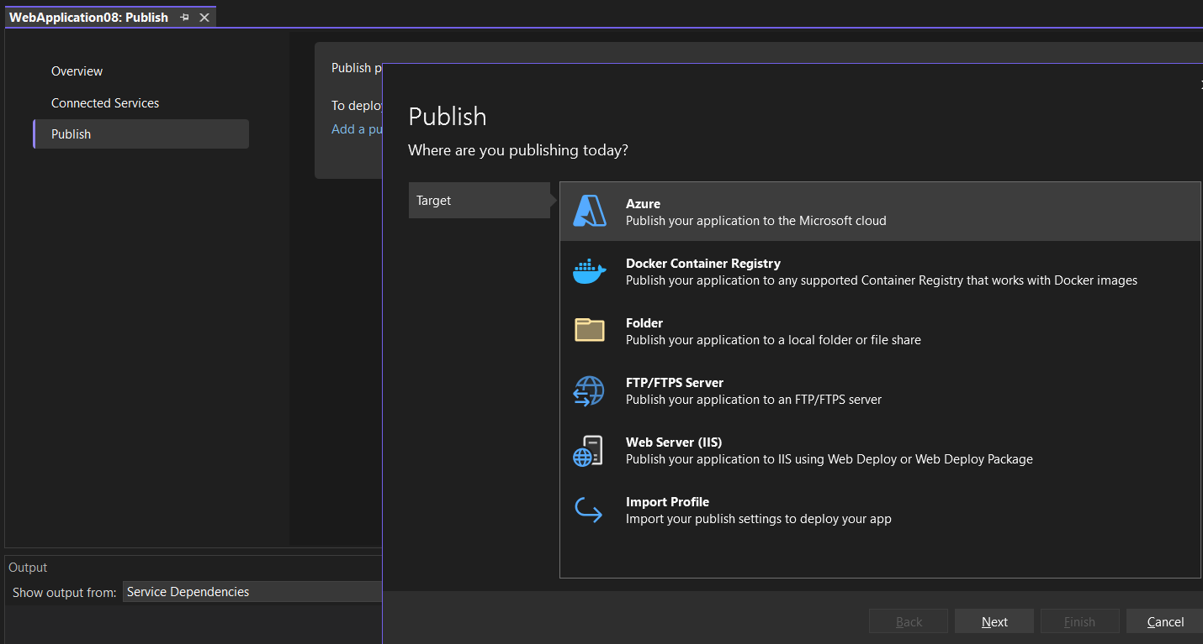

Select the windows because my web app is based on windows OS.

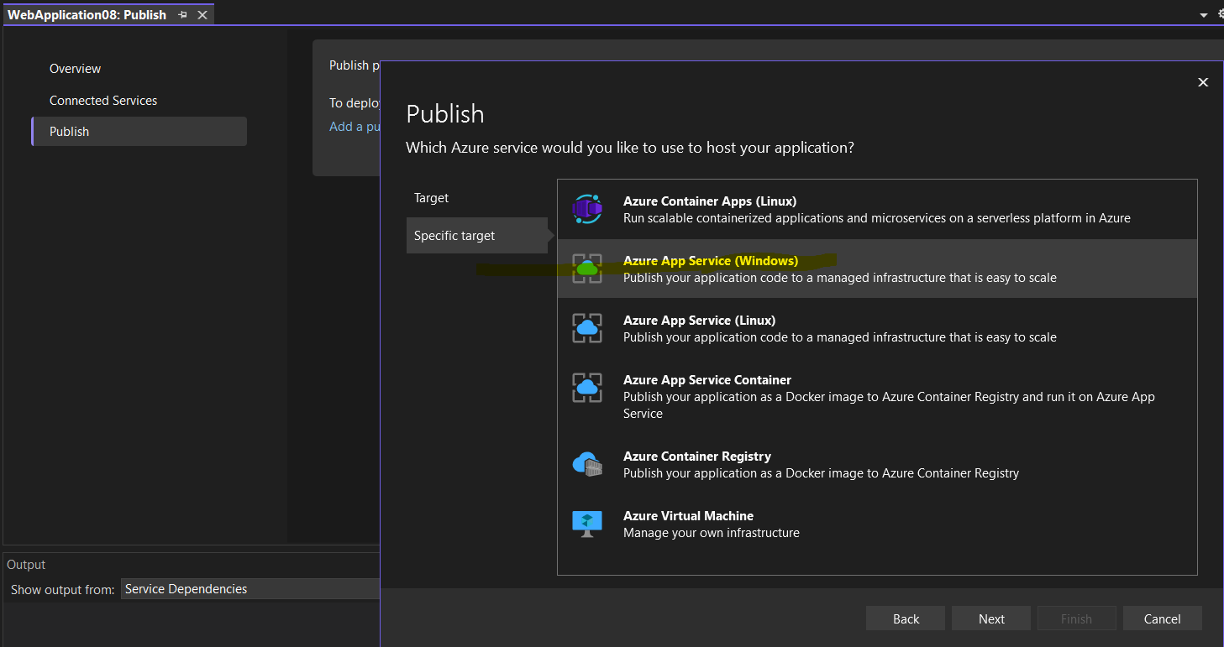

Select the web app name, click on the finish.

Click on the publish.

This will build your application locally and publish your application on azure web app.

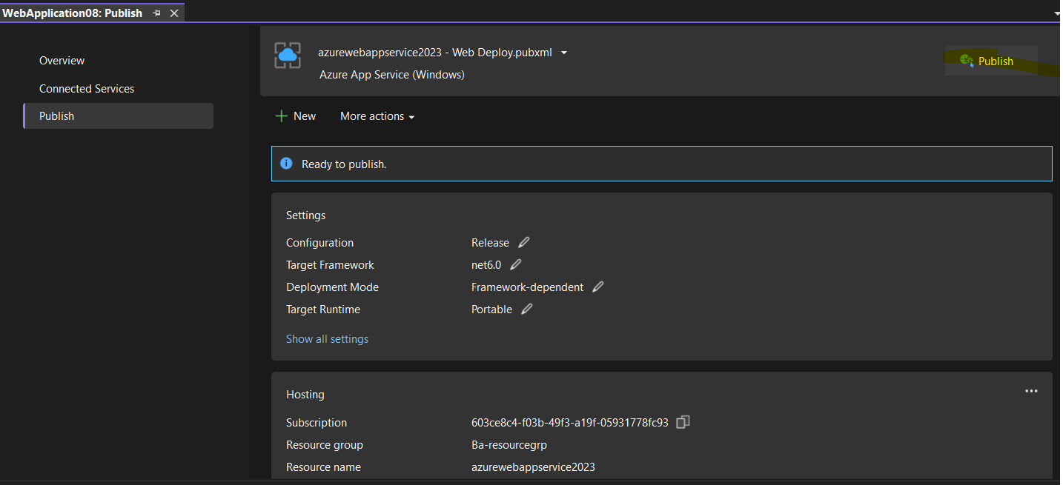

**Azure Web App – Deployment slot.**

This slot act like seperate web app in place.

Application in the deployment slot having their own host name.

You have chance to validate all application and changes in the staging deployment slot. You can swap the staging slot to production slot base bose the version update (if you do any changes). This help elimination the downtime for your application when new changes are deploy. You can also rollback the changes.

You have to work with deployment slot you have to ensure that App service plan is standard app service plan or higher.

Scale up feacture is used for the to choose the teir of the app service plan.

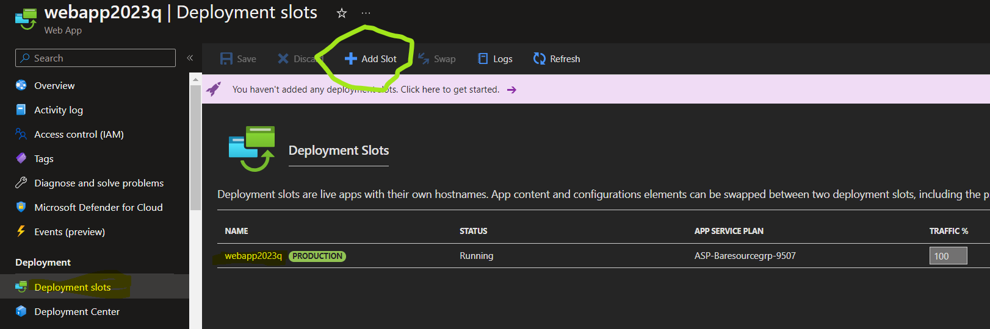

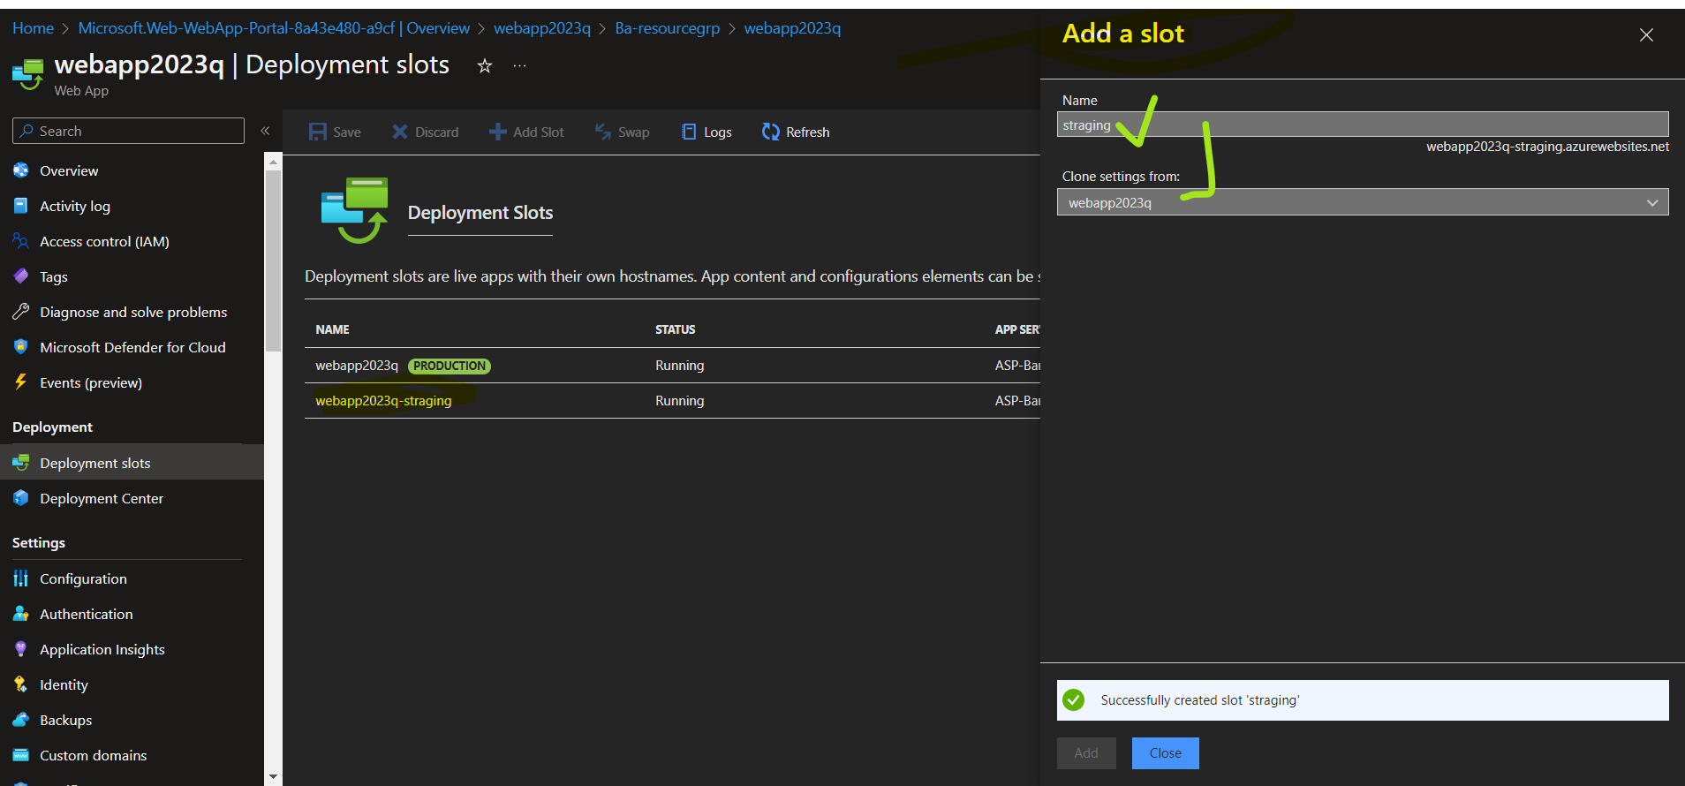

You can swap the web app services

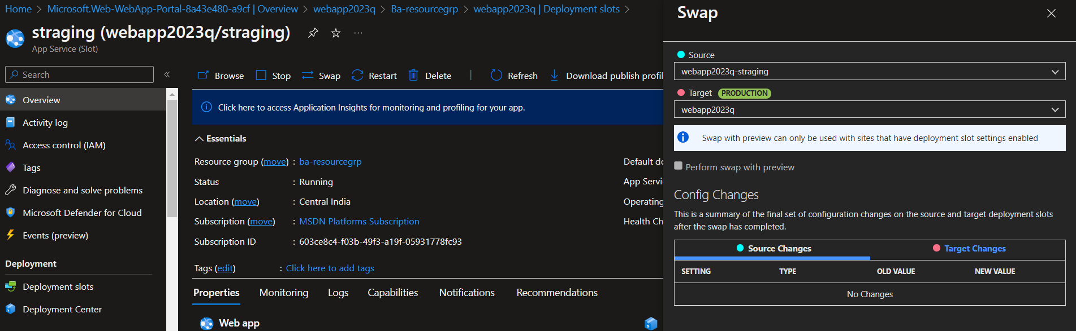

You didn’t see any changes after swapping but the changes is done. And copy the url and past the new tab for your understanding purpose.

Under deployment slot you can see all the things are same.

**Auto Scaling a web app.**

Scale out feacture is used for the auto scaling purpose.

Under the web app servcie you can select the auto instance count up to 10 based on the standard app service plan. This process have to change based on the what app service plan to selected (premium =30 / basic =3 / standard = 10 instance count).

**Note**- to select the basic tier under scale up wizard you have only manual scale option see.

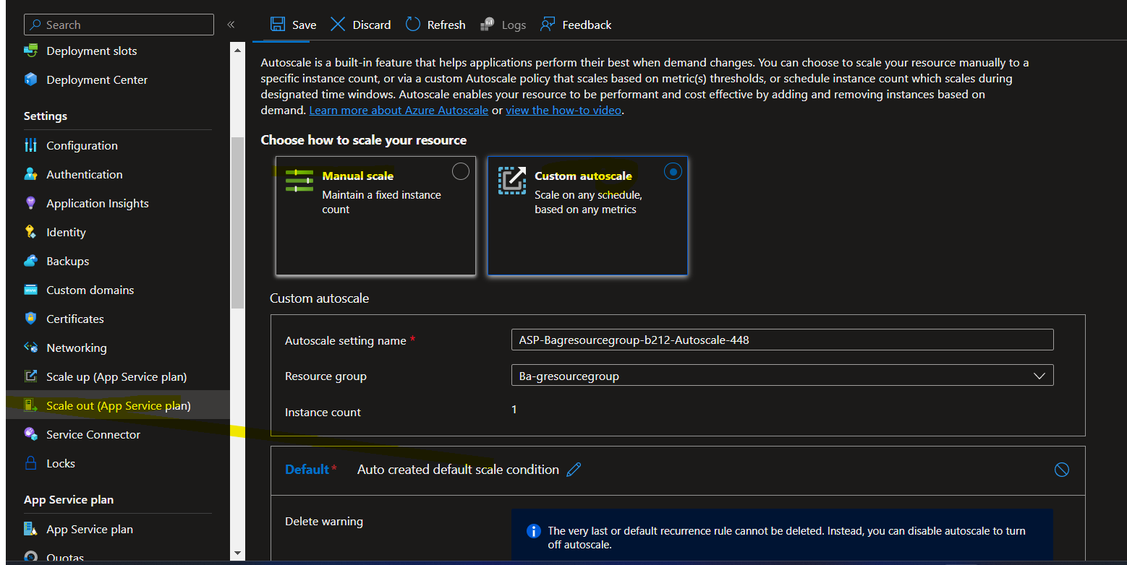

**Azure web app Vnet integration**

Create one VM and inside the VM download the mysql community

